
Meeting Professionals International
CVENT CUSTOMER SUCCESS
U.S. and Canada (toll-free): 866.318.4357
UK (toll-free): 0808.234.4543
Australia (toll-free): 1800.502.472
All others and local: 703.226.3535

customercare@cvent.com



USER GUIDE

Version 2: as of April 2026

Contents
Administrative Support 4
New Users 4
Account Email Addresses 4
Contact Groups 4
Merchant Accounts 4
Billing Statements 4
Access Portal 4
Attendee Management 4
Attendee Management General Checklist 5
Event Creation 5
Invitations 6
Customization 7
Testing 7
Launch Event 7
After the Event is Launched 7
Post Launch Reminders 7
Key Definitions 7
Creating a New Event Registration Site from a Template 8
Selecting the Event Site Features 9
Updating Registration Types 9
SSO to MPI Membership 9
Designing the Event Website 10
Navigating to the Site Designer 10
Navigating Between Pages in the Site Designer 10
Header and Footer Customization 11
Adding Images to and from the Media Library 11
More on the Site Designer 12
Adding Virtual Information 12
Event Level 12
Adding Speakers to the Event Registration Site 12
Adding Sessions 13
Managing Registration Paths 14
Changing Registration Path Content 14
Adding a New Registration Path 15
Hotel Requests 16
Adding Hotels 16
Adding Rooms 17
Flight Requests 17
CONTACT GROUP CREATION - WITH VISIBILITY STEPS AND NAMING CONVENTION 18
Importing Contacts 19
Adding Contacts to Event: 25
Managing Invitation Lists 26
Select the Import Method and Matching Setting 26
Select the Import File 26
Map Fields in the Import to Fields in Cvent 27
Associate the Imported Contacts 28
Confirm the Import Setting 28
Update Planner Alerts 29
Managing Event Emails 30
Sending an Invitation 30
Changing Email Content 30
Schedule Emails 32
Using events for Standalone emails (Newsletters and Board Nominations) 32
Managing Invitation Responses 32
Testing and Launching the Event 33
Testing the Event 33
Launching the Event 33
Create a Feedback Survey 33
Event Level Reporting 33
Running a Report 33
Setting the Report’s Criteria 34
Filtering the Report 34
Editing Grid Settings 34
Saving and Exporting Report Data 35
Best Practices 36
Assistance and Resources 36
Cvent Community & Customer Care 36
Training Opportunities 37

OVERVIEW
This guide was created for use of MPI Chapters working within the MPI Global Account: MPIFOUN001.

Administrative Support

New Users
During onboarding into the MPI Global account, a list of account users was shared and created. If you require changes to your chapter’s current list of users, either deleting or adding, please contact the dedicated MPI System Administrators for changes.

Account Email Addresses
Need to add new email addresses for sending out communication in chapter specific events, please contact System Admins.
Contact Groups
In order to create contact groups for a specific chapter, please reach out to the System Admins.

Merchant Accounts
If you want to create a Cvent Payments account, the chapter admin can create it on their own by following the steps in the article.
If you have a third-party merchant account (Authorize.net, PayPal, Stripe etc), reach out to the System Admins to set this up on your behalf.

Billing Statements
If you want the billing statements for a specific time period for a specific chapter, please share the details with the System Admins. and they would share it with you.

Access Portal
To ensure effective content management within our single Access Portal, please create dedicated portal user groups for your chapter. When adding content, share it exclusively with the appropriate user group for your chapter, rather than with all portal users. This will help maintain targeted access and ensure that only relevant users can view the shared materials.
Content Publishing: Please follow the steps in the article to publish reports to the Access Portal for specific chapter users only.
NOTE: Please note that there is a single Access Portal for the entire account. When managing users, groups, or content within the portal, only make changes related to your own chapter’s users. Do not modify, add, or remove users, groups, or content associated with other chapters. This ensures data integrity and maintains appropriate access controls for all chapters.

Attendee Management
This section is intended to be used by planners to leverage the MPI event templates and manage registrations in Cvent.

Attendee Management General Checklist

Event Creation
- Did I use one of the MPI Account Event Templates?
  - Choose from the following Templates:
    - Affiliate Membership Event-DO NOT EDIT or DELETE (Event Code: PJNBPK88NVP)
    - Education Event Template-DO NOT EDIT or DELETE (Event Code: S5NXDMDWNCW)
    - Networking Event Template-DO NOT EDIT or DELETE (Event Code: P7NVHRDKZ8K)
  - NOTE: Please do not edit or delete any items in the event templates.
- Is the Event Capacity set? (Registration > Registration Settings)
  - Tip: This number should include both registrants and their guests, if applicable.
  - Tip: Leave blank if unlimited.
  - Verify that the basic details are correct: Start/End date, Registration Deadline and Planner Name and Email Address are correct, and that Location is entered.
- Is the time zone selected set for the location of the event?
  - Tip: This will affect the “Add to Calendar” button.
- Are all of my settings configured correctly in General > Event Features?
  - Common settings to have on: Sessions, Fees, Hotel Accommodations, Air Travel, Guest Registration, Registration Types, Email Invitations, Waitlist.
- If using Sessions, are they configured under Agenda > Session List?
  - Tip: Use Optional Sessions if collecting RSVPs for a headcount. Common examples are workshops and meals. Included sessions are included for all registrants of this event – so the headcount will be the same as for the overall event.
- If using Hotel Accommodation, is it configured under Travel > Hotel Accommodations?
  - Tip: Use advanced rules to setup different default check-in and check-out dates for different registration types.
- If using Air Travel (GetThere/Concur, Air Requests or Air Actuals), is it configured under Travel > Air Travel?
- Did I create all necessary registration paths under Registration > Registration Process?
  - Tip: Create and perfect the default path and use that to copy for others to save time if multiple paths are necessary
  - Tip: Make sure all registration paths are linked to a registration type. Multiple registration types can link to a single registration path.
- Did I customize the registration experience under Registration > Registration Process?
  - Am I using the registration types configured in the template?
- Using the registration types provided will allow for the use of the integration that confirms MPI membership type -
  - Is the guest or group registration feature turned on?
  - Am I allowing registrants to modify or cancel, or add themselves to the waitlist?
  - Am I collecting and requiring the correct contact fields (Company, phone number, etc.)
  - Do I have all the registration questions created that I need?
    - Select certain registration questions to only be available for certain registration types.
    - Insert a question code to be able to insert a question into emails and reporting with a data tag/field.
    - Select whether the question should be included in the “Current Registration” data tag if you are planning to use it in any emails.
    - If passport information is required, use the encrypted contact fields, not a registration question.
  - Tip: When setting up the registration process, make sure to turn on all the information you need for reporting purposes and make them required.
- Is my graphic currently at the top of the website? (Website > Open Site Designer)
- Did I review the Event by clicking “Preview” in the top right corner?
  - Tip: In Preview, all the pages you see on this screen are Website Pages.
  - Tip: In Preview, after clicking the register button, all the subsequent pages are Registration Pages.

Invitations
- Did I import my contacts in the Address Book?
- Did I customize the following emails?
  - Invitation
  - Registration Confirmation
  - Regret
  - Invitation Reminder
  - Event Reminder
- Did I customize my emails?
  - Tip: Use data tags like a mail merge to insert someone’s First Name, Current Registration Details, Itinerary Details, etc.
  - Tip: Update all plain text emails (copy from html).
- Did I turn on all of the emails that I want to send under Emails > Event Emails?
  - Tip: If allowing registration cancellation and/or modification, activate the Modification Cancellation and Cancellation Confirmation emails so registrants will receive confirmation that they have successfully modified or cancelled their registration.
- Invitation Lists
  - Tip: Assign registration type to each invitation list.
  - Tip: If using multiple invitation lists, upload a separate excel file for each registration type (only one tab per spreadsheet).
  - After uploading invitation lists, review invitees to see if any were automatically “opted out” and opt back in prior to distributing the invite (this can be done in bulk if needed via contact import) Advanced Filter: Confirmed Opted-in.
  - Run the import summary report to see if any records were skipped.

Customization
- If using the Branding Package, did I customize my weblinks?
  - Tip: Create event specific URLs to dictate how the URL appears, maintain branding requirements, and control where invitees go from the link.
- Did I check the Event Calendar Settings?

Testing
- Did I send out test invitations and test register to proofread the website, registration pages, invitation, and confirmation emails?
- Did I double-check that this meeting is confidential and not searchable via Internet Search Engines? (General > Event Settings > Security)
- Did I confirm any contact fields that I uploaded are prepopulating during the registration process?

Launch Event
- Did I launch my event after testing was completed? (Home > Feature Status)
- Have I fixed any warnings that displayed during Event Validation?
- Did I schedule the invitation email to be sent or did I manually send the invitation?
  - Tip: Launching the event does not automatically send the invitations. This must be done next.

After the Event is Launched
- Have I set up any necessary Planner Alerts?
- Have I run reports in the Reports section?
  - Tip: Reports can be marked as Favourites and run on the Event Overview screen.
- Have I saved reports?
- Did I create a Post Event Feedback Survey?
- Did I schedule the Post Event Survey Email to be sent the day after the meeting ends?

Post Launch Reminders
- An event cannot be moved back to test mode or delete it once it has been launched.
- Once someone registers for an item, it can not be deleted.

Key Definitions
Term | Definition
Registration Path | Customizable flows for different attendee types (e.g., member, non-member)
Dues Collection | Process of collecting membership fees during registration
AMS Integration | Syncing registration data with Aptify

Creating a New Event Registration Site from a Template
- Log into your Cvent Account using the MPI Global Account number: MPIFOUN001
- Select Events in the blue App Switcher menu to view all events.
- Click on Create Event.
- Select Use template as the creation method.
- Select from the MPI templates to adopt the template’s event features and event registration website design.
  - Affiliate Membership Event-DO NOT EDIT or DELETE (Event Code: PJNBPK88NVP)
  - Education Event Template-DO NOT EDIT or DELETE (Event Code: S5NXDMDWNCW)
  - Networking Event Template-DO NOT EDIT or DELETE (Event Code: P7NVHRDKZ8K)
NOTE: Please do not edit or delete any items in the event templates.
- Fill in the details in all sections, making sure to complete all the required fields marked with a red asterisk.
  - The data on this page will populate the first Summary page of the registration site and other widgets, so it is important to fill in as much as possible or go back and update it later.
  - Planner Email in particular is important to select when setting up the event, as it will default as the email address that event emails come from, so choosing the correct address now will save a lot of time in setting up emails later.
  - Find the included features from the event template in the box on the right.
- Update the custom fields
  - Select the meeting type and meeting format
  - Choose whether or not this event should display on the Global event calendar
  - Select the Region
  - Select the MPI Chapter or Club
- Click Create event.

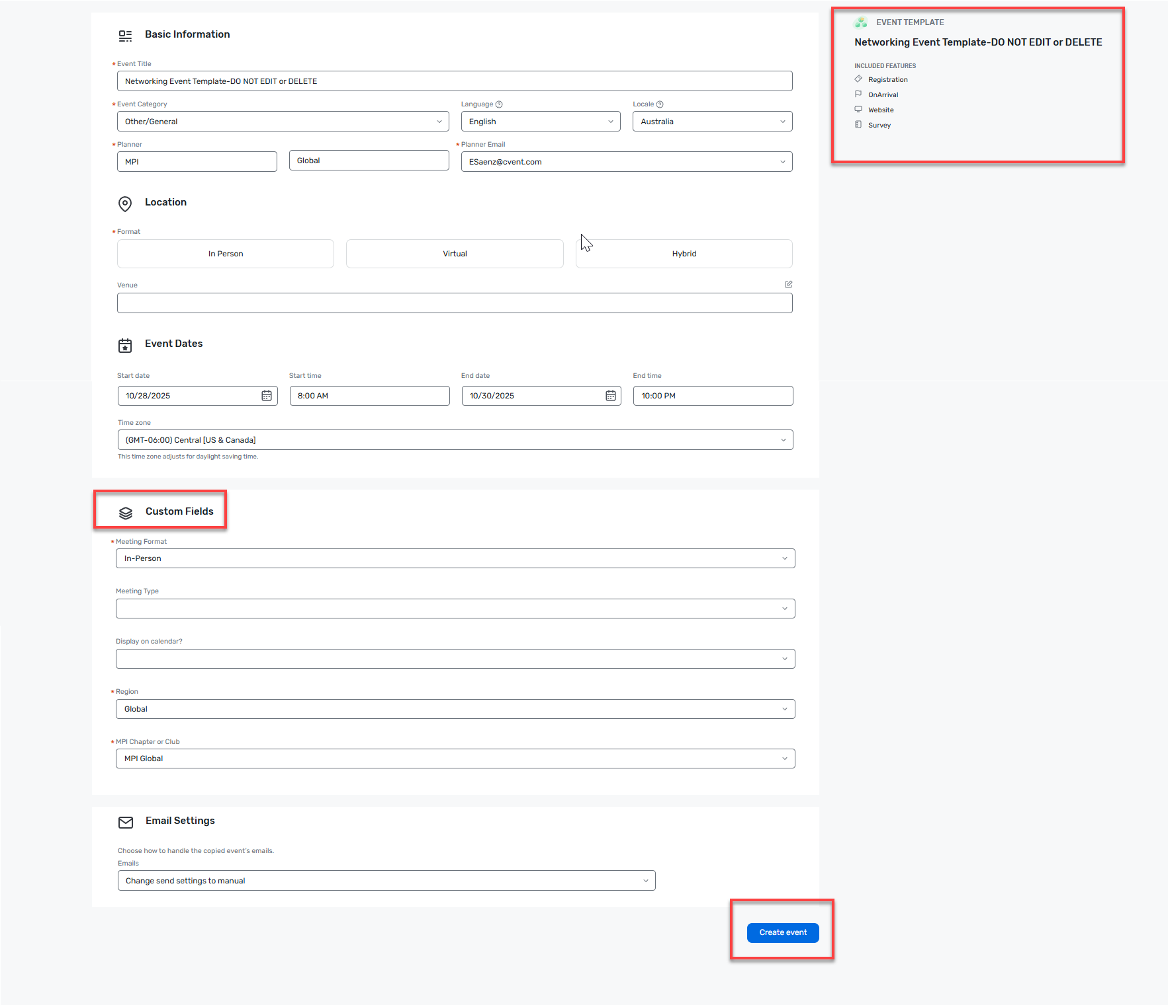

Selecting the Event Site Features
- Since this is a template set up for this meeting type, there are some features which are included with it, and should not be turned off unless they are not necessary for the new meeting.
- Additional features can be added by navigating to Event Features on the left hand menu.

Updating Registration Types
The template includes commonly used registration types for MPI, but more can be added/removed. For information on how to add registration types to events, please refer to this article on the Cvent Support Community.

SSO to MPI Membership
During the registration process, an invitee will be redirected to login on MPI’s website to authenticate their membership status. The registration experience is below:
- The invitee clicks on “member” button if they are a member and “Non-Member” button for the event.
- When an invitee selects the 'Member' button during the registration process, they will be redirected to the MPI Global Website to log in with their MPI Global credentials. This integration ensures that the user’s membership status is verified and validated directly by MPI Global. Upon successful authentication, the system will automatically assign the appropriate registration type based on the user’s current membership status. This process helps maintain accurate registration records and ensures that only verified members receive the correct fees.
- When an invitee selects the 'Non-Member' button, they will follow a separate registration path. There is no integration with MPI Global for this path. The user will be assigned the 'Non-Member' registration type and will see the corresponding non-member pricing.

Designing the Event Website

Navigating to the Site Designer
- Click Website.
- Either click on Open Site Designer to access all the pages or select Customize to go to the specific website page.
- Confirm the site-wide Theme settings before editing individual pages and sections.
- Use the Change Theme button to select from some pre-created themes, or configure a new Theme by applying a logo, header background, colors, and fonts.
- The Theme will take effect site-wide so that individual widgets throughout the website and registration pages don’t need to be updated.
- Once Theme updates are complete, click Finished at the bottom.

NOTE: Finished must be selected in the theme menu before any other website content can be edited.

Navigating Between Pages in the Site Designer
- Click the Website Page dropdown menu at the top left to open the menu of configurable web pages.
- Click on the name of a page to edit it.
- Once selected, click the settings (gear) icon to change the settings for that page such as the names that appear in the navigation bar and browser tab for web pages, and the registration types, basic, privacy, group, and advanced settings for registration pages.
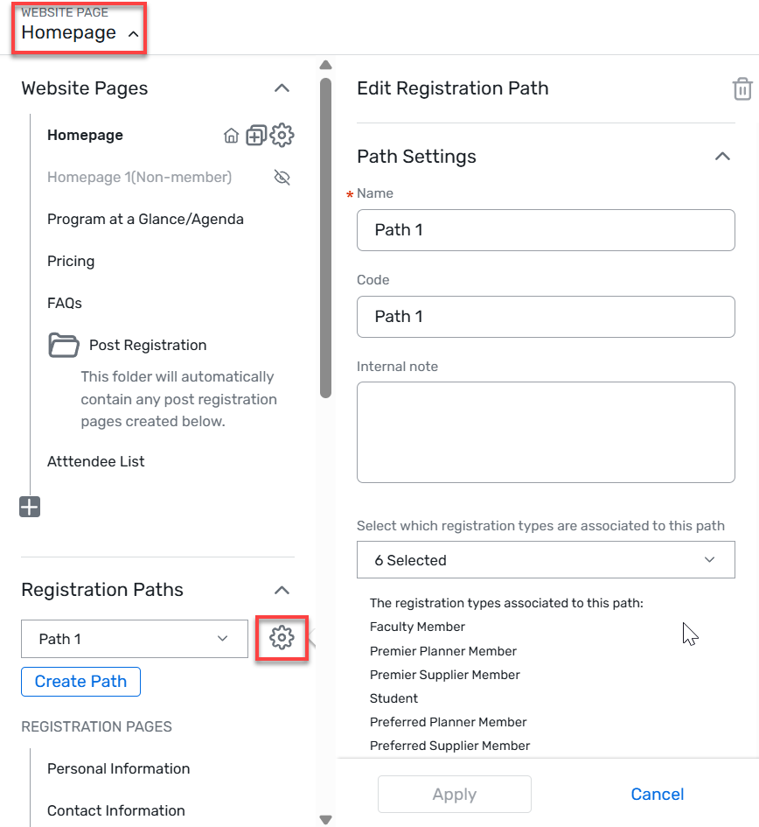

Header and Footer Customization
- When clicking at the top or the bottom of the page, a message pops up, requiring a move to another section of the Site Designer.
- Click Edit Header and Footer to change images and content in the header and footer.
- From the left side Website Page Menu, the menu that appears when the gear icon is selected provides the option to apply a header to or remove it from a page of the event website or registration process.

Adding Images to and from the Media Library
- To add images to the templates, such as the header image, the images need to be stored in the Media Library.
  - Images can be added or replaced in the template by clicking on an image, and then in the right-side Image menu, choose Replace.
- An Add from Library menu opens. Click on the image file name and select the image to add.
- Or, to upload a new image to the Media Library, choose one of these options:
  - Search for your chapter folder within the Media Library
  - Upload a new image 
NOTE: Within the MPI Global account, all images should be saved within your chapter folder. Do NOT create new folders within the library for specific events. Contact the dedicated system administrators with any questions.

More on the Site Designer
Cvent's Site Designer allows for customization of website and registration that is device responsive. Adding headers, placing register buttons, customizing the theme, using widgets, and incorporating motion are important to building out webpages. Reference this article for a list of common Site Designer terms.
For a few more site designer tips and tricks, check out these articles:
  - Site Designer Basics
  - Creating Additional Custom Website Pages
  - Publishing A Website
  - Editing the Header or Footer
  - Limit Visibility for a text box, question, or field

Adding Virtual Information

Event Level
- To add virtual meeting information, go to the navigation bar, click Event Settings under General and then select the Virtual Event tab.
- Click Edit and choose the virtual platform.
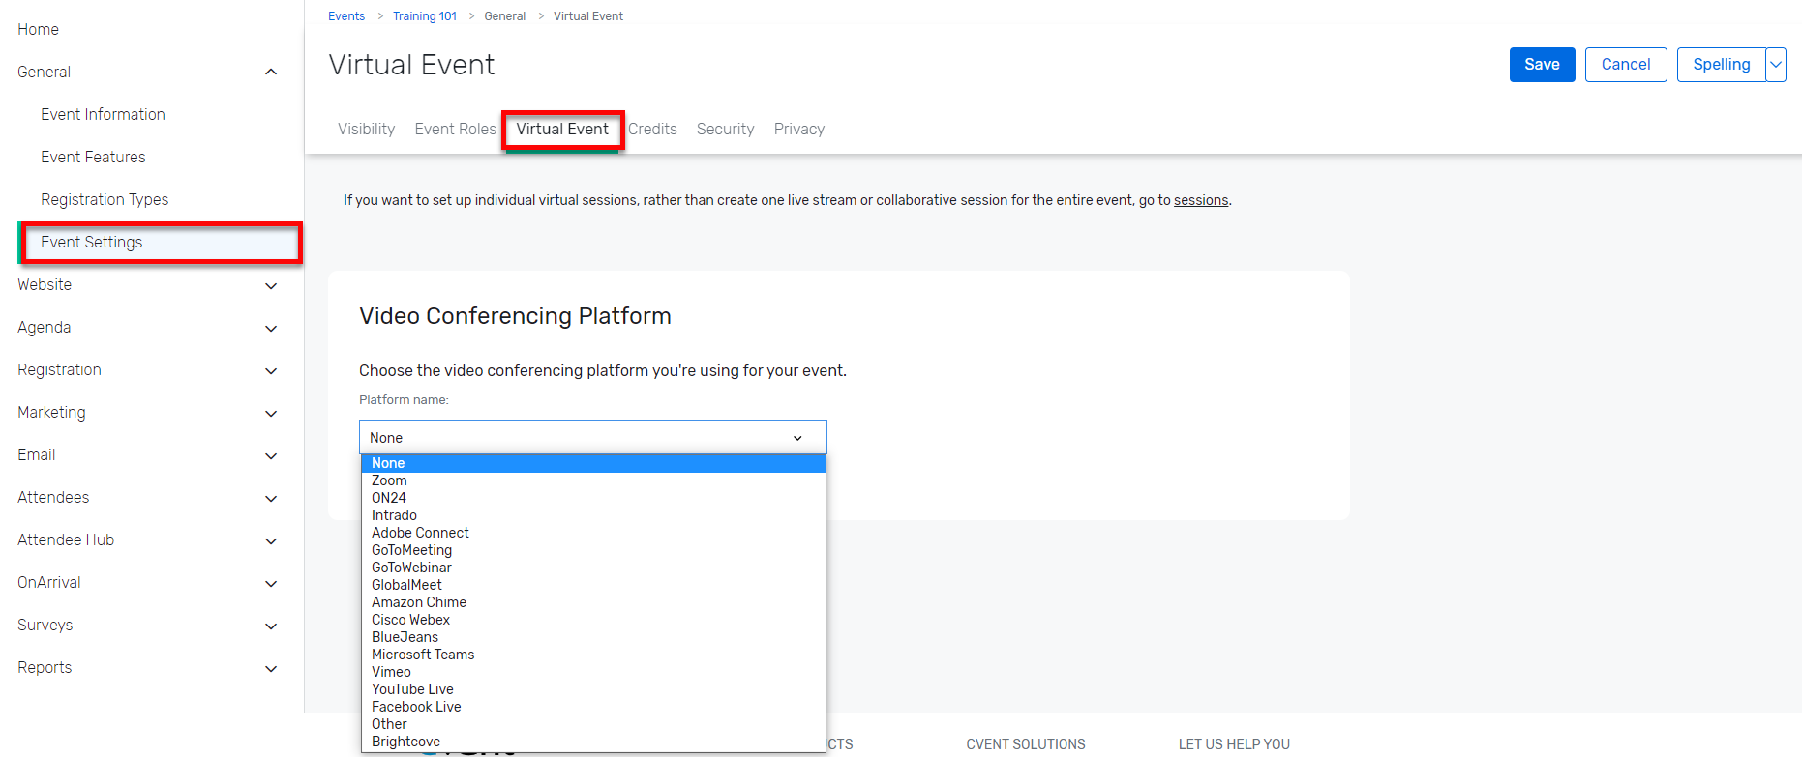
- Enter the necessary virtual information and click Save.

Adding Speakers to the Event Registration Site
- Certain registration site pages, such as the Speakers page, will not show up unless they have content.
- To add a speaker to the event, from the navigation bar, select Speaker List from the dropdown menu under Speakers.
- There are three ways to add a speaker to an event:
- Create Speaker
- Add from Library
- Import
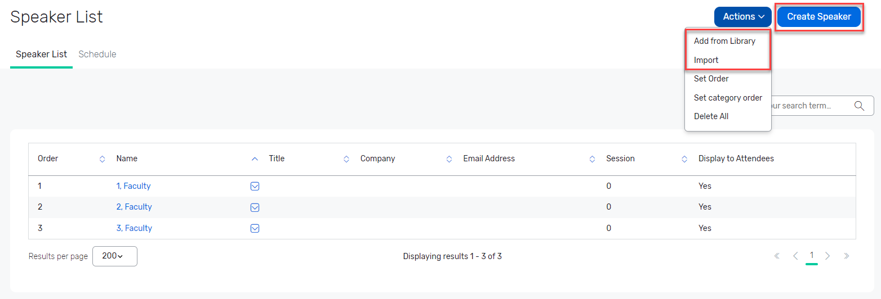

- If creating a new speaker, the next page has fields to enter speaker information, add documents associated with the speaker and assign the event Session at which they will present. Then, click Save.
- Control if certain speaker information displays on the site or not by toggling “Display to Attendees” to yes or no.
- The speaker is automatically added to the registration site.
- If adding from the library, the speakers need to be added by an Administrator before they are available for site builders to select within an event.
- When in the Site Designer, there are more options as to what speaker information is ultimately displayed on the Speakers page (it must be turned on in the Event Configuration).
- Drag the Speakers widget onto the Canvas. When the widget is selected, a menu will appear on the right to edit the widget’s settings.
- Use Display Options to turn on or off information such as Profile Image, Prefix, Title, and Company.
- To display additional information, click on More Speaker Details and an additional menu of speaker data can be turned on or off.

Adding Sessions
- Certain events require the addition of Agenda Items which are called Sessions.
- To add an item, under Agenda click on Session List.
- To create a Session, click on the Create Session button and begin filling out the information.
- To add a specific session category that groups sessions together or a location for the session, click on the ellipsis and a pop-up box will appear.
- Sessions can be Included or Optional.
  - Included adds sessions to every attendee’s agenda.
  - Optional provides the attendees the option to select the sessions in the registration process and each item can have its own individual capacities, added fees and many more features.
  - All sessions, included or not, have the option for the planner to display or not display on the agenda.
- Sessions Groups:
  - Set rules such as “an attendee must select at least one of the sessions from this session group” or “an attendee cannot select more than 1 session from this session group”.
  - Session groups also dictate how these optional sessions will display during the registration process.

Managing Registration Paths
The Registration Path feature allows for the website pages and registration process to be customized across registration types. For example, as seen in the pictures below, the event has Path 1 for MPI members and Path 1 for non-members.

Changing Registration Path Content
- To change the registration path for an existing registration type, go to Registration and click on Registration Process.
- At the next page, click on Customize to the right of the Registration Process Pages, or click on the Open Site Designer button.
- Hover over the top right Registration Page menu to open the left side navigation menu.
- Pick a Registration Path (Employees in the example below) and then edit the page(s) just for that path.
- Select the contact group the attendees should be added to depending on the chapter the event is for.
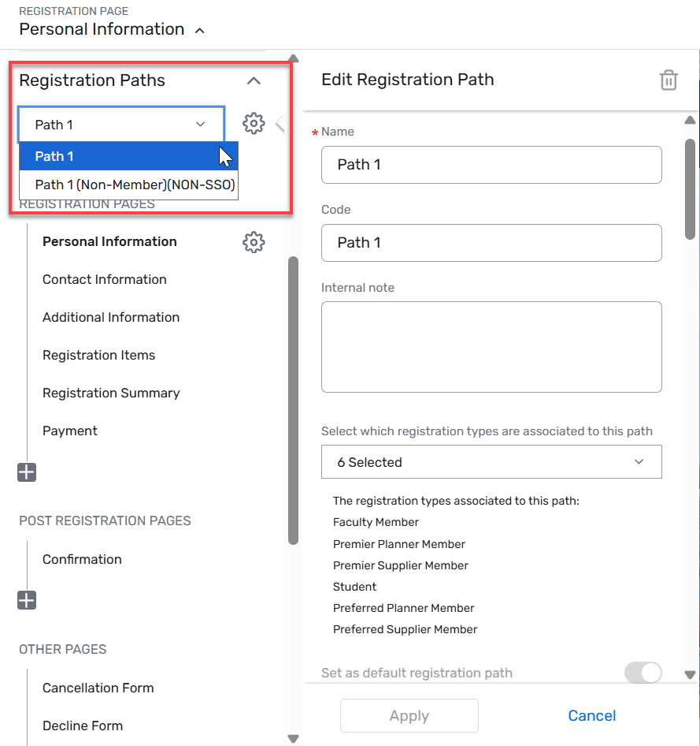
IMPORTANT: For all new events, you’ll need to add registered invitees to a contact group. MPI Global’s account requires all events to use this feature for your attendees to be added to the address book within a contact group that is visible to only your chapter.
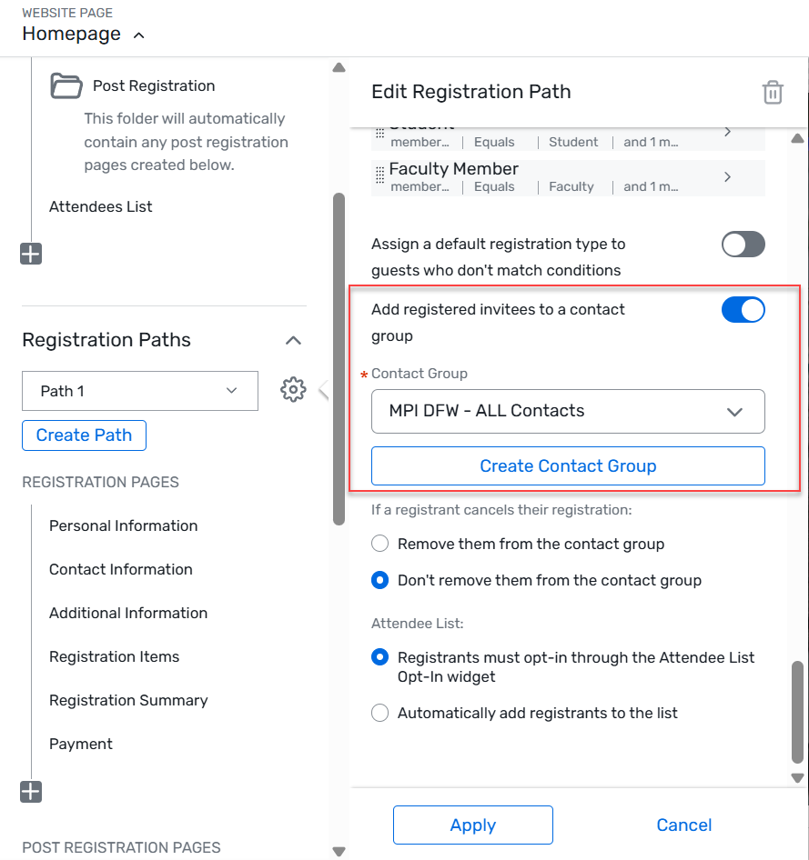

Adding a New Registration Path
- If a new registration type needs to be created, this is done outside the Site Designer.
- Navigate to the General tab and select Registration Types.
- Click Edit and click Create Contact Type.
- Create the Contact Type, which also serves as a registration type.
- Once named, Save and then click on the name of the registration type to configure it for the event.
- Click Edit and add the settings, such as Capacity to limit the number of registrants for this path, associate them with a specific Invitation List, and indicate the Sessions the registrant will have the opportunity to see or for which they can register.
- Once this is complete, navigate to the Site Designer for the Registration Pages.
- Click Create Path to create a new path OR associate the new registration type to an existing Path, which opens side navigation.
- Once the new path is named and associated with a registration type, click Create and design custom pages for that path.
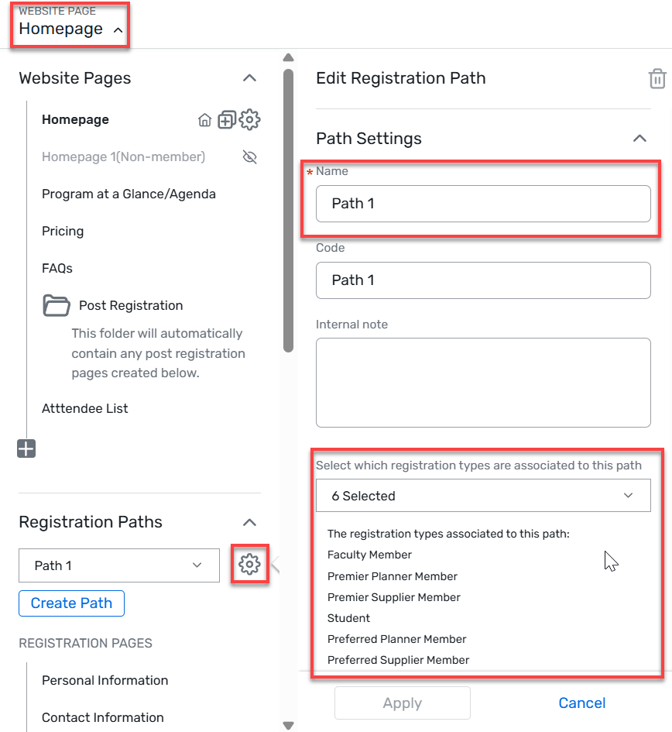

Hotel Requests
The Hotel Request form collects rooming dates and preferences from attendees and helps ensure everyone gets pre-negotiated rates. Follow the steps below to add hotels and rooms to an event and allow registrants to request rooms during registration.
Adding Hotels
- From the left-hand navigation, under Travel, click Hotel Accommodations.
- Click Create Hotel.
- Decide how to add the hotel. Options include:
  - A new hotel - Enter the hotel name and any additional details. Any hotel created here will be added to the account-wide list found in Admin. To avoid duplicates, it is recommended to try the other options first.
  - Using a hotel from this account - Click the ellipses (...), then Select next to the hotel's name. All hotels listed here are part of the account-wide list found in Admin.
  - Using a hotel from the Cvent Supplier Network - Click the ellipses (...), then choose a metro area from the dropdown. Narrow the search further by including the name, chain affiliation, or brand. Click Search, then Select next to the hotel's name.
- Scroll to the Basic Settings section. Ensure Yes is selected next to "Open for registration." Add a cancellation policy.
- Click Save.
- Choose to control the hotel visibility by registration type or admission item.
- From the left-hand navigation, click Travel, then Hotel Accommodations.
- The Hotels tab opens by default. Click the neighbouring tab, Hotel Request Setup. Then click Edit.
- Select to control the hotel visibility by registration type or admission item, then click Save.
- Even after adding a hotel, invitees can't complete a request until rooms have been added.

NOTE: Hotel profiles are account wide. Never edit a hotel to change it to a different property. This will edit the property name on every event that hotel has been added to. Always remove the existing property and add the new hotel.
Adding Rooms
- From the left-hand navigation, click Travel, then Hotel Accommodations.
- Select a hotel by clicking its name.
- Click Create Room Type. Name the room type and enter the minimum number of nights an invitee can book for. Ensure "Open for registration" is switched to Yes.
- Specify whether registrants will be sharing the room, the number of occupants per room, and how these rates will be charged (a flat nightly fee or different prices for each registration type).
- Enter the number of rooms that are available. Add room rates for each registration path.
- Click Save.
- Click the neighboring tab, Advanced Settings, then Edit.
- If room rates are set up, switch "Charge registrants for this hotel room" to Yes. If the room is free, leave this as No. Depending on how hotel visibility is controlled, select which admission items or registration types to associate to this room.
- Click Save. If desired, repeat this step to add additional room types.
- To create room blocks, click Close, then Manage Room Block.
- Enter capacities in the textboxes under each date. When room types are combined, the capacities are added together. When room blocks are separated, the combined capacity will stay with the first room type.
- To combine room types, check the boxes under the Select column and click Combine.
- To separate room types, check the boxes under the Select column and click Separate.
- To create sub-blocks, click Create Sub-Block. Select a room type and registration type from the dropdowns. Use the text boxes to specify how many rooms to reserve per night.
- Click Save.

Additional information on hotel requests can be found in the Cvent community.

Flight Requests
- From the left-hand navigation, click Travel, then Air Travel.
- Click Edit. Specify which fields to include on the air request form. Check the boxes to make each type of ticket selectable during registration.
- In the Restrictions section, enter the earliest departure date and latest possible return date. To define airport options, select Yes for both radio buttons. Click Add Airport and begin typing the desired airport.
- Make registration quicker by designating default airports and arrival and departure times. Do not worry if these do not apply to everyone, since invitees can change flight defaults during registration.
- Under the Default Schedule section, type a city into the Departing from/Returning to and Arriving at/Returning from textboxes and select the airport from the list that appears below each field. Enter the default departing and returning dates as well.
- Click Save.

Additional information on air requests can be found in the Cvent community.

CONTACT GROUP CREATION - WITH VISIBILITY STEPS AND NAMING CONVENTION

When creating contact groups, it’s important to follow the MPI naming convention for easier identification. The naming convention is: MPI [Chapter Name] [List Name]
Creating Contact Group
- In the top nav, click on Appswitcher in top-right > go to Contacts.
- Click the Contact Groups tab.
- Click Create Contact Group (blue button, top‑right).
- Choose Type = Standard List
- Name the group as per the naming convention
- Under ‘Contact Group Visibility’ select the users that are associated with your Chapter list and click on Save.

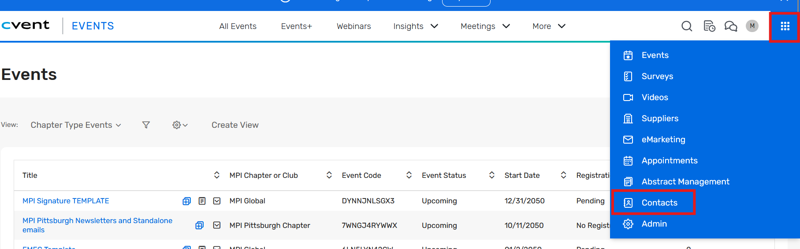
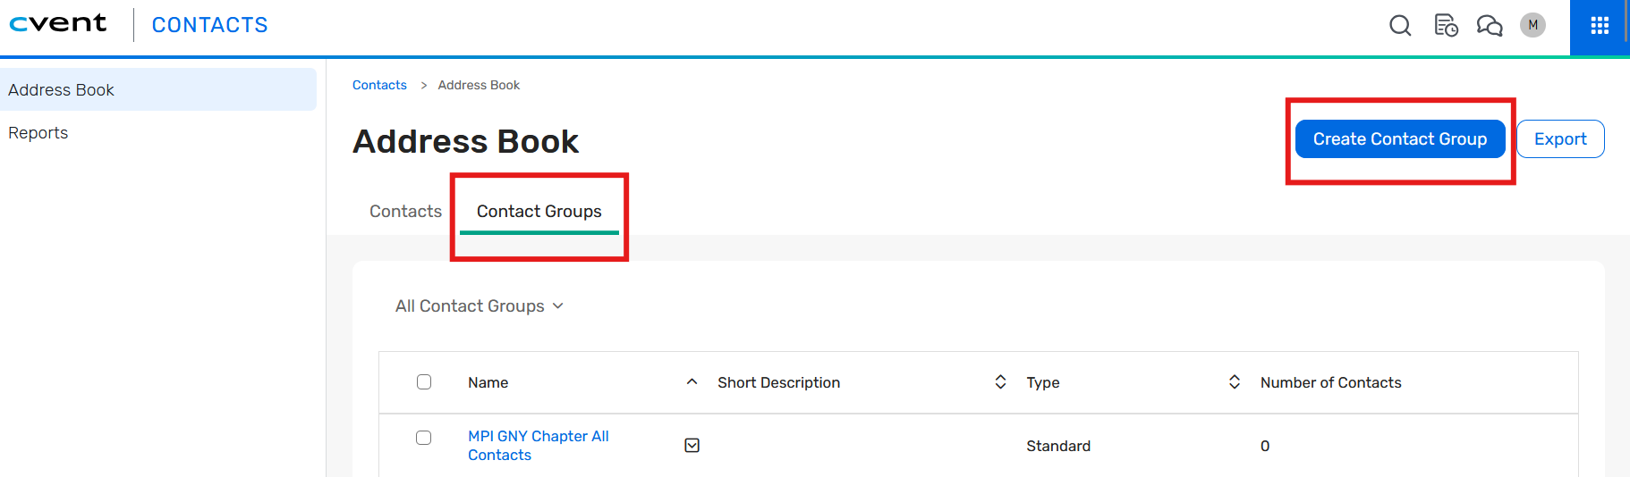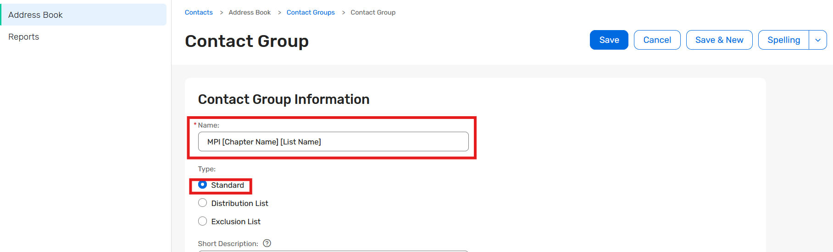
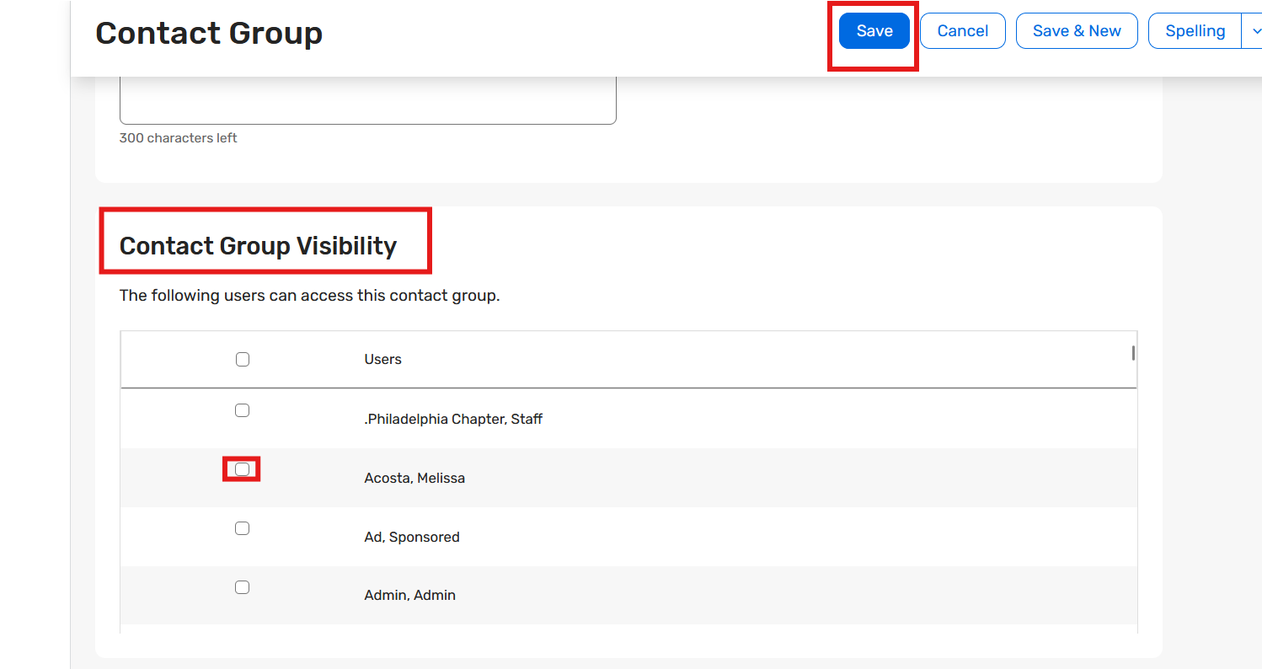

Refer to these Community Articles for more information
Managing your Address Book
Managing Contact Groups
How do I add a single contact to a group?
Managing Contacts
Merging Contacts
Exporting Contacts

Importing Contacts
Refer to the community article for more information
Importing Event Contacts
NOTE: When importing contacts into the account or event, it is essential to select the appropriate contact group to which the contacts should be added. This ensures that each contact is correctly categorized and that access to information remains restricted to the relevant chapter only

Importing Contacts to the Contact Group:
Prepare your Excel file with the details of the contacts and ensure that the required fields such as: Email, First Name, Last Name columns are present.
- In the top nav, click on Appswitcher in top-right > go to Contacts
- Click Import.
- Select ‘Import Source:’ as ‘Data file’ > Click on Next.
Under Step 1: Select the Import Method and Matching Setting
- For ‘Import Method:’ select ‘Insert new contacts and update existing contacts’
- For ‘Match contacts by:’ Select ‘Email Address’ > Click on Next
Under ‘Step 2: Select the Import File’
- Upload the prepared file by clicking the ‘Browse’ button
Under ‘Step 3: Map Fields in the Import File to Fields in Cvent’
- Map the fields in your prepared file to the Cvent fields.
Under ‘Step 4: Associate the Imported Contacts’
- We will select the Contact group to which the Contacts would be added.
- Click on the ‘Add Contact Group’ button
- If adding the records to an existing contact group, select ‘Add to an existing group’ and type the keyword or the name of the group and click on search button in the bottom right of the pop-up window.
- Select the contact group from the list by click in the ‘Select’ option.
- If adding the records to a new contact group which is not present in the account, select ‘Add to a new group’ and type the name in the name field as per the naming convention for Contact group (MPI [Chapter Name] [List Name]) and click on Save to create the group (Once the import process is completed please follow the above-mentioned steps to update the Contact Group Visibility).
- Once you have selected the contact group or created a new one, click on Next button by scrolling towards bottom of the page.
- Once you have reviewed the selected settings and options, Click Finish to start the import and add the contacts to the selected group.
Note: It is very important to maintain contact group visibility so that each chapter’s contacts/members are visible to its own chapter administrators only.
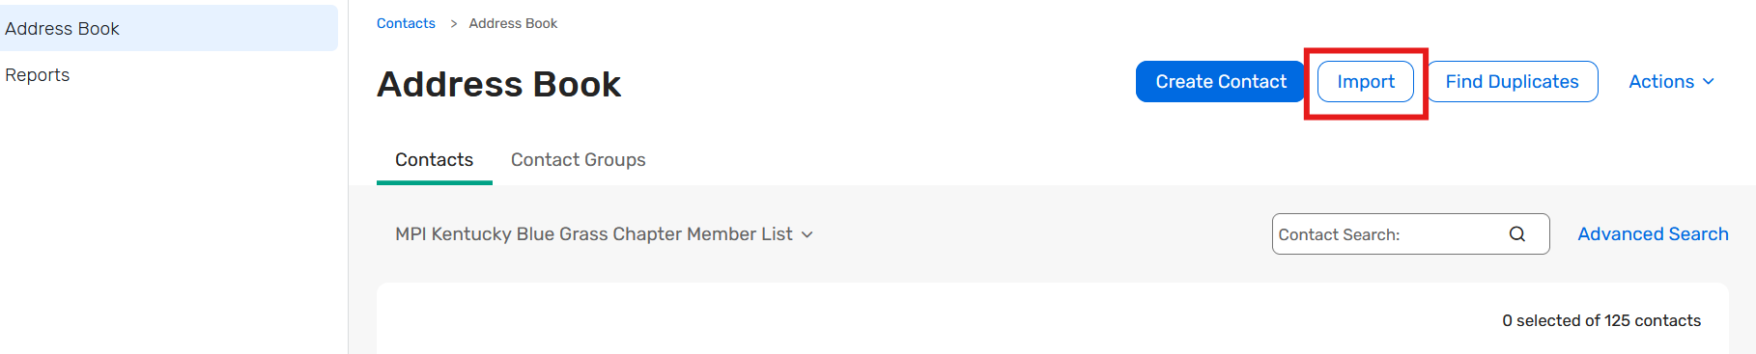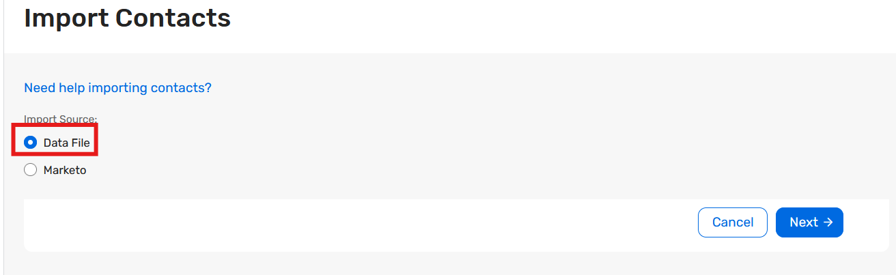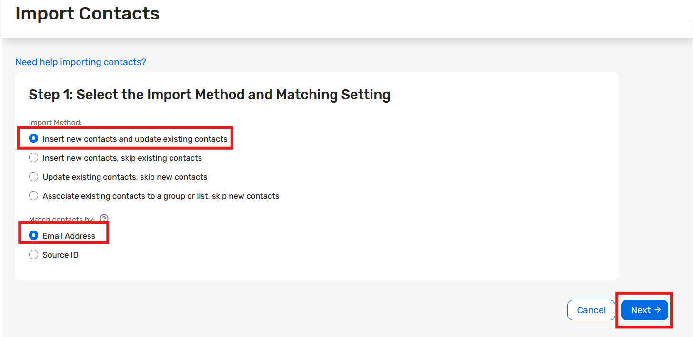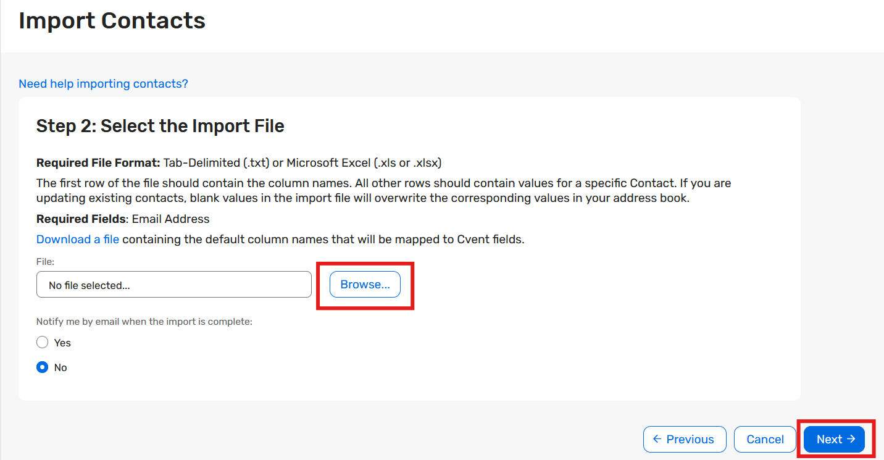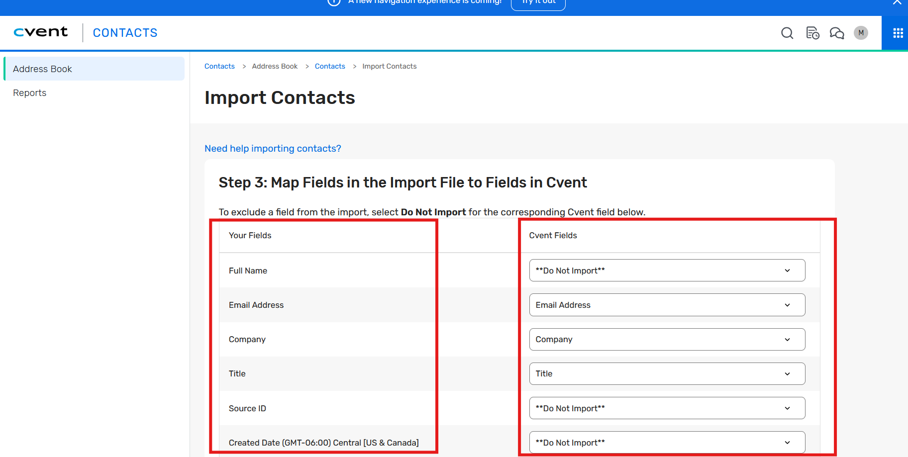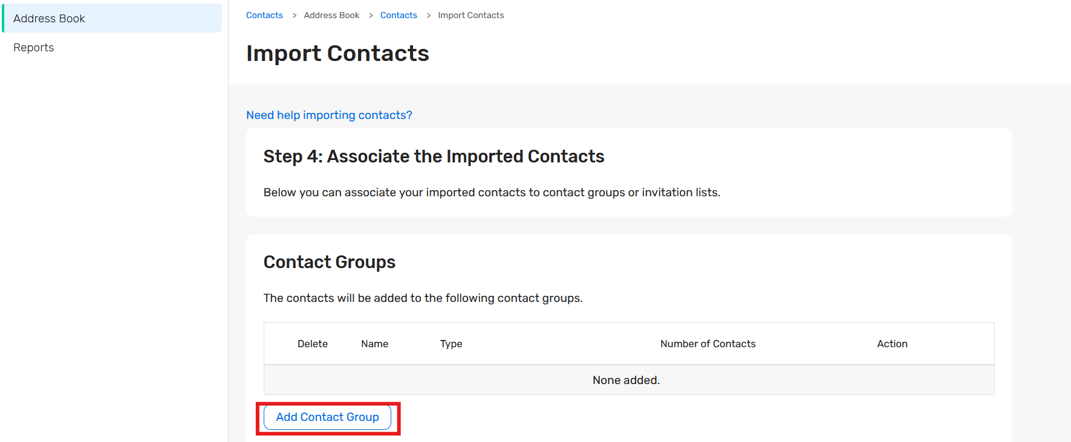
If Adding contacts to an existing contact group
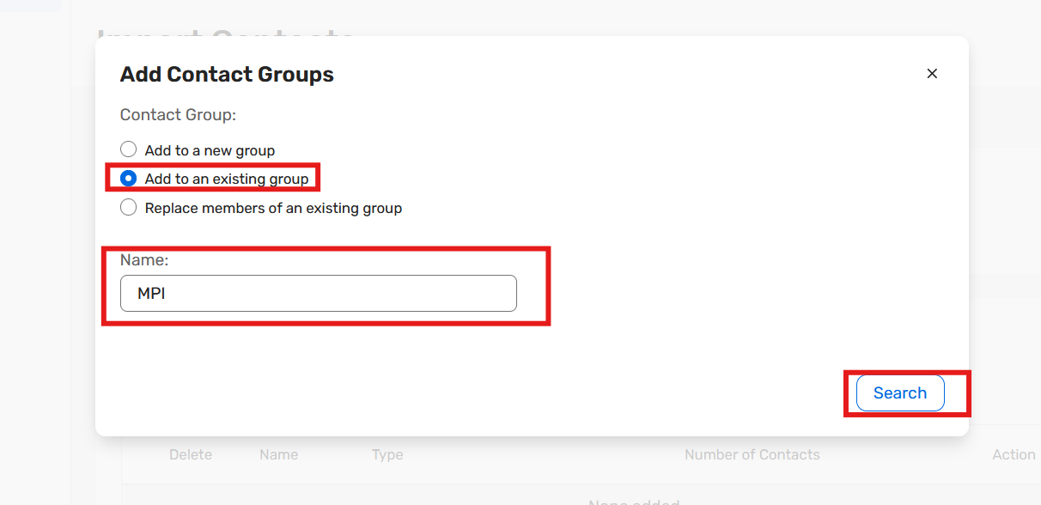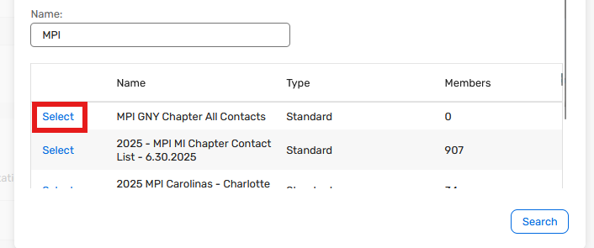

If creating a new contact group
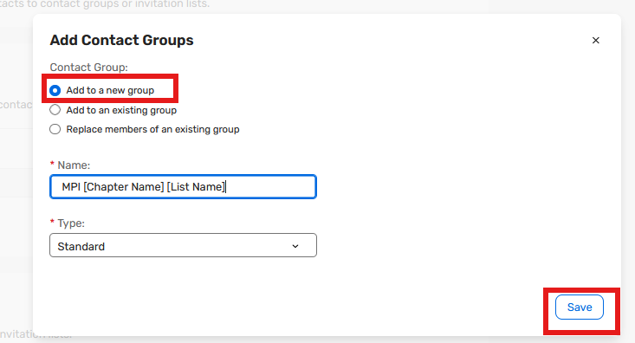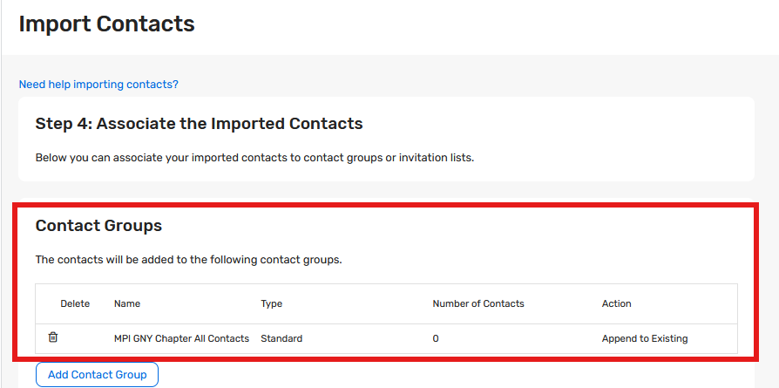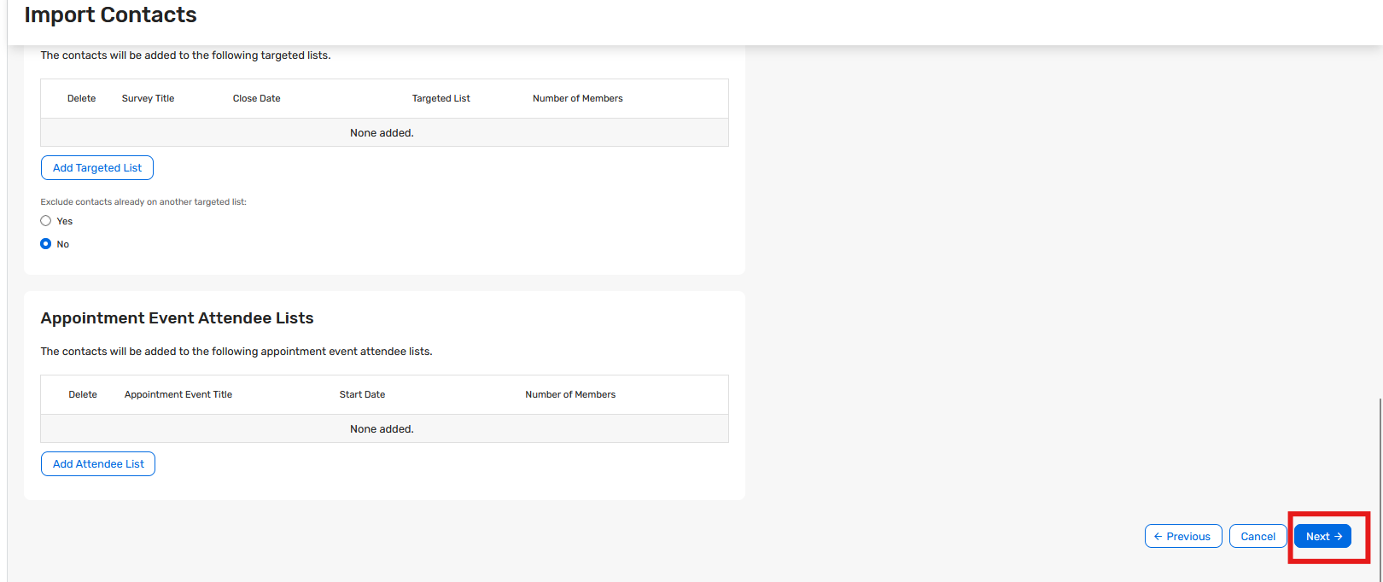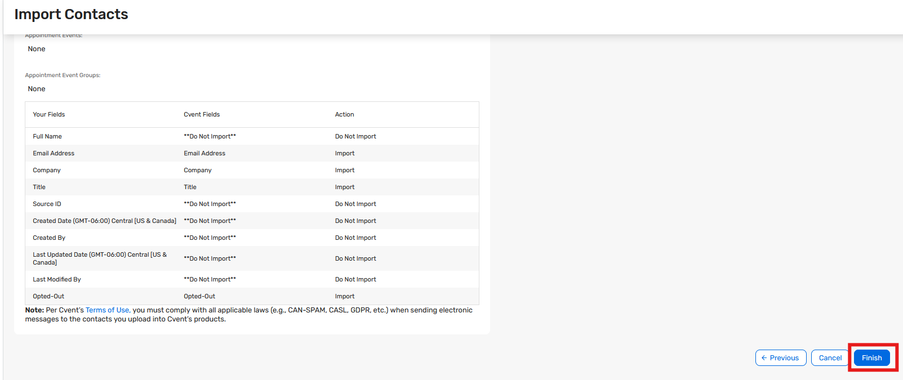

Adding Contacts to Event:
When adding contacts to the event it is important to note that we are adding correct member/distribution list which are the correct audience for the respective MPI Chapter’s event. Please follow the below-mentioned steps to add the correct contacts to your event:
- Go to Event > Emails > Invitation List > List Members
- Click Add Contacts from Address Book
- From the dropdown, select the contact group which has your invitees.
- Select all contacts
- Click Add
If you want to add invitees from multiple groups, please follow the above steps again.
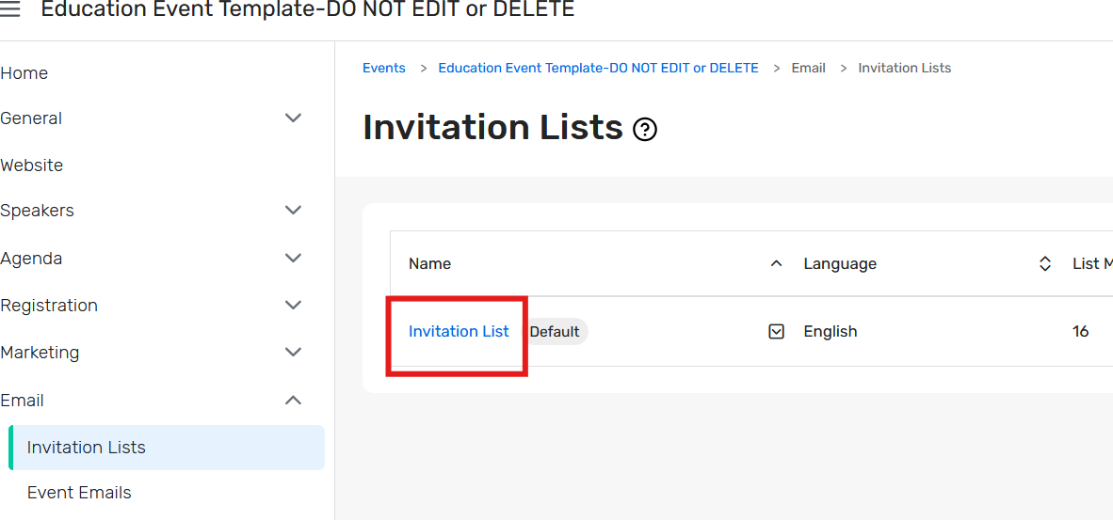
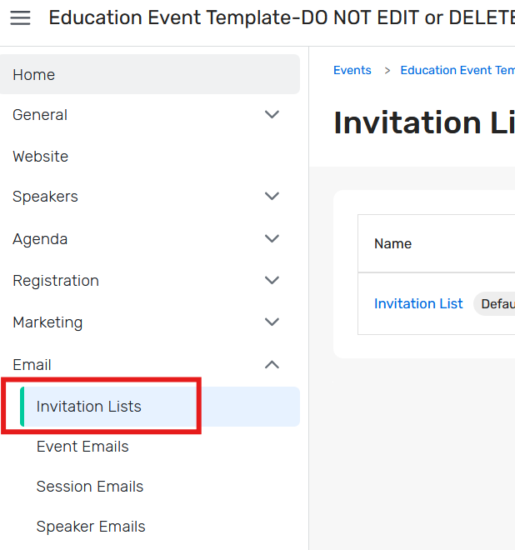

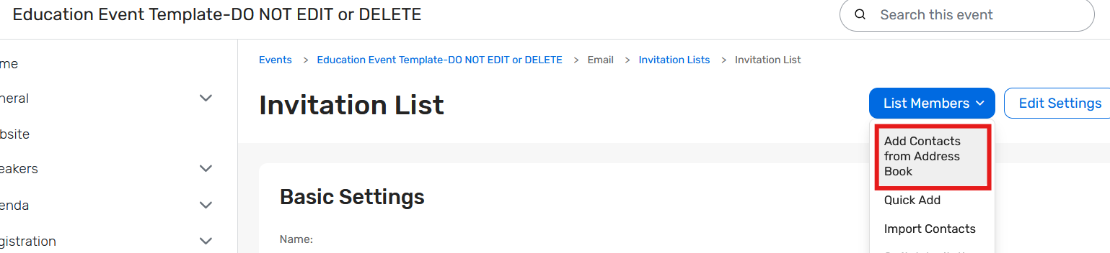

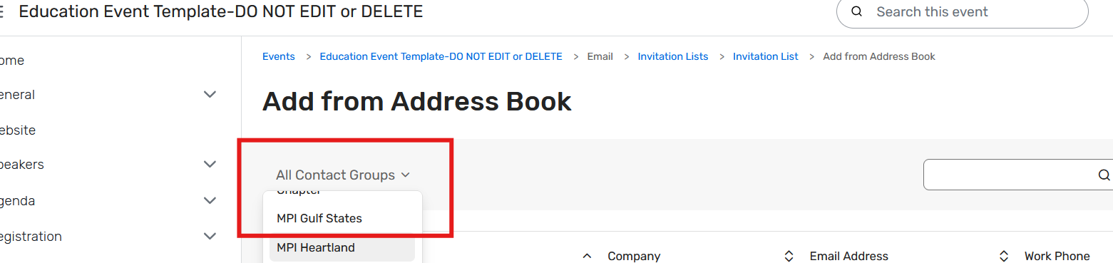

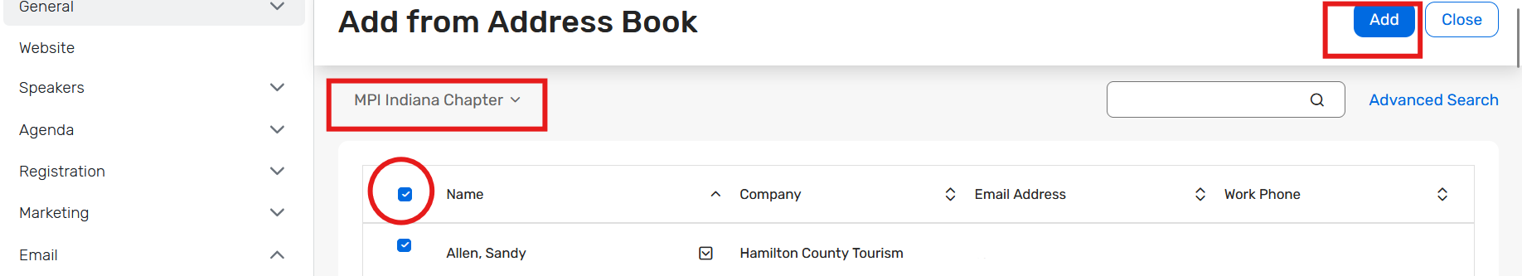

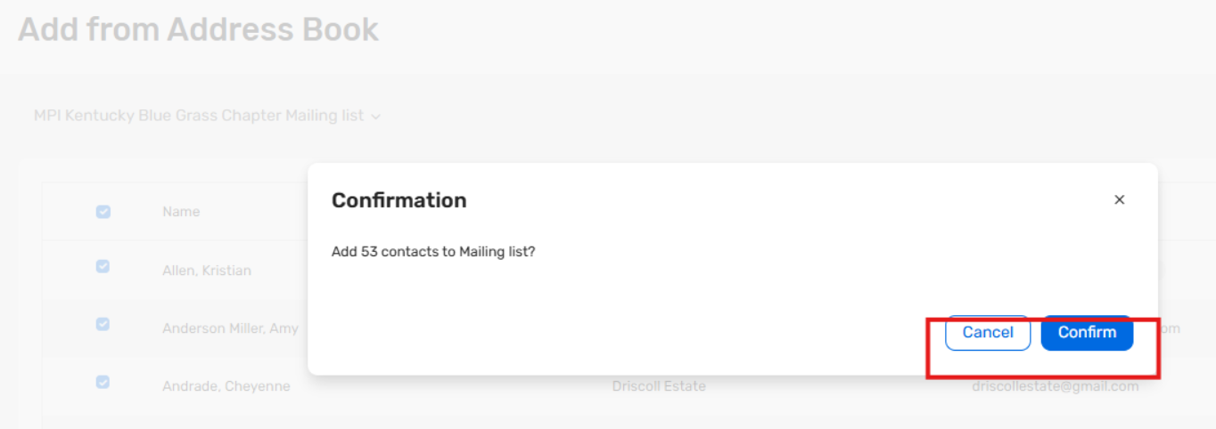

Managing Invitation Lists
- To set up an invitation list, go to Email and select Invitation Lists.
- For event templates with multiple Registration Types, where the registration type is pre-determined using invitation lists, an invitation list must be created for each type as the example shows below.
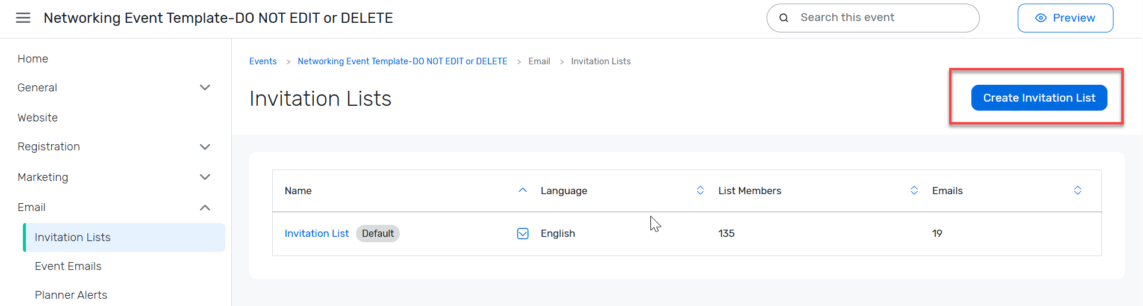
- To add to the existing list, click the list name.
- To create a new list, click the Create Invitation List button.
- Once in the new list, under the Advanced Settings section, select Yes for “Assign registration type to list members who register” and associate the appropriate contact type to the list, then click Save.
- Click on the Invitation list to add invitees to and at the next page, hover over the List Members button.
- Select Import Contacts from the drop-down menu.

Select the Import Method and Matching Setting
- Select Insert new contacts and update existing contacts, from the Import Method menu. This will ensure that the most recent information populates for registrants when they visit the event website and begin the registration process.
- Select Email Address from the Match contact by menu. Email address is the unique identifier for registrants, and then click Next.

Select the Import File
- Click on Download a file.
- Copy the text header and paste into Excel.
- Make sure the import file is in the same format as the sample template. Do not change the header names or order of the columns.
- Enter invitee data into the Excel file.

**IMPORTANT GUIDELINES**
  - Registrant information that is imported will update that registrant’s information on an ACCOUNT WIDE basis.
  - This means that information like a registrant’s Contact Type (Registration Type) will not only upload into this event but will change their Registration Type for EVERY other event they are registered for in the system along with the registration path, settings, and options for that Registration Type/Path. Do not do this!
  - To avoid this, any fields that should not be updated in EVERY event should removed from the import file, as any blanks will delete existing information.
  - RULE OF THUMB:
    - Information that should be the same in all events – Import.
    - Information that varies from event to event – remove column.
    - **Remember** – The Registration Type is assigned simply by adding the invitee to this special invitation list, so a Contact Type is not needed on the import to do this. That was already taken care of in the Advanced Settings when creating the invitee list.
    - Do not change the headers or the import will not work.
    - Because Registration Types are assigned by their associated Invitee List, a separate Import File is needed for each Registration Type.
    - Upload the appropriate file for the current Invitation List to Cvent and click Next and then confirm the upload.

Map Fields in the Import to Fields in Cvent
- Ensure that the correct Import Field headers are mapped to the correct Cvent Fields.
- Choose **DO NOT IMPORT** for any fields that were left blank in the excel document. (The information like Contact Type that will be unique in every event mentioned above)

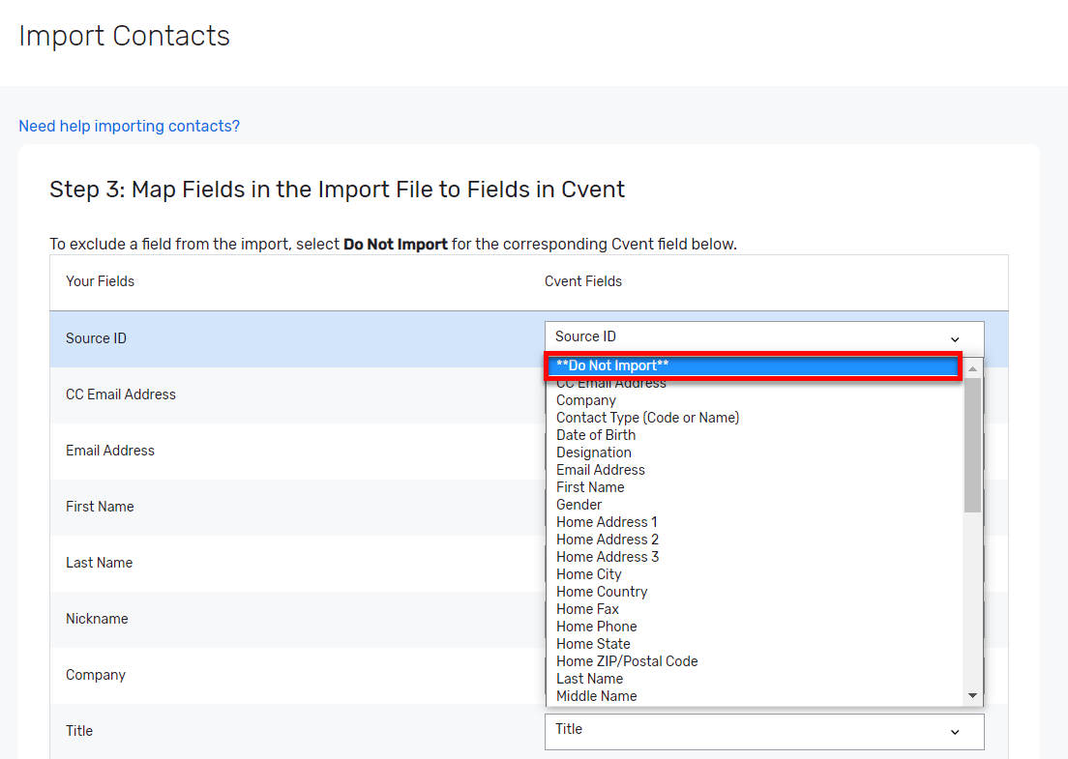

Associate the Imported Contacts
- Near the end of the import process, there is an option to create a Contact Group. Select your Chapter’s Contact Group
- Invitation lists can be imported for each event based on their updated information from external systems.

Confirm the Import Setting
- Click Finish at the bottom if all the settings appear to be correct.
- As an additional step, ensure that Registration Type Selection settings are set so that they DO NOT update the contact’s primary record with registration type changes. This can be updated by going to the registration path within the Site Designer, click settings (gear) icon and under Advanced Settings ensure Update the attendee’s contact record with any registration type changes is turned off.
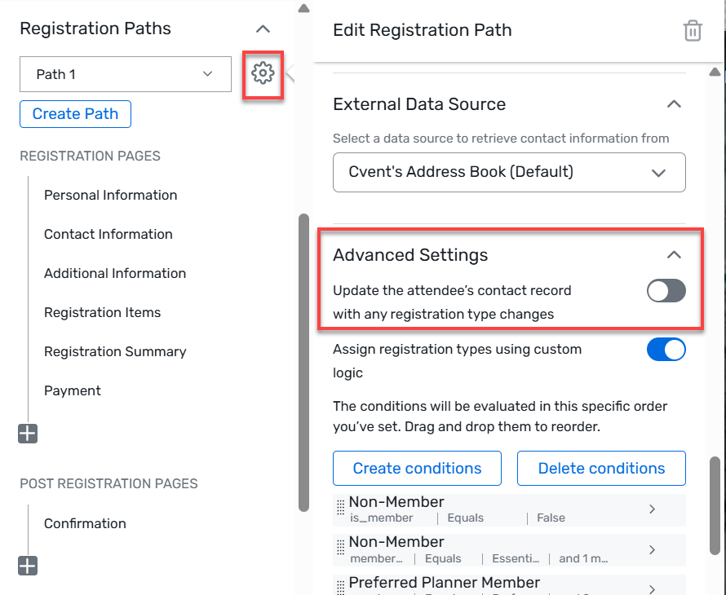

Update Planner Alerts
Planner alerts notify of developments within a specific event. Pre-existing planner alert can be updated, or new planner alerts created by following the steps below. For more information on planner alerts, refer to this article in the Cvent Support Community.
- Under the Email section, choose Planner Alerts.
- Click into the name of the alert you are editing, or click Create Alert.
- Establish planner alert details.
- Select the recipient(s) of the email.
- Click Finish.

Managing Event Emails

Sending an Invitation
- Emails can be sent automatically at different stages of the registration process or can be sent manually.
- To access the emails, go to Email and select Event Emails from the dropdown.
- For Events with different Registration Types, first select the desired Invitation List, as emails are customizable for each Invitation List.
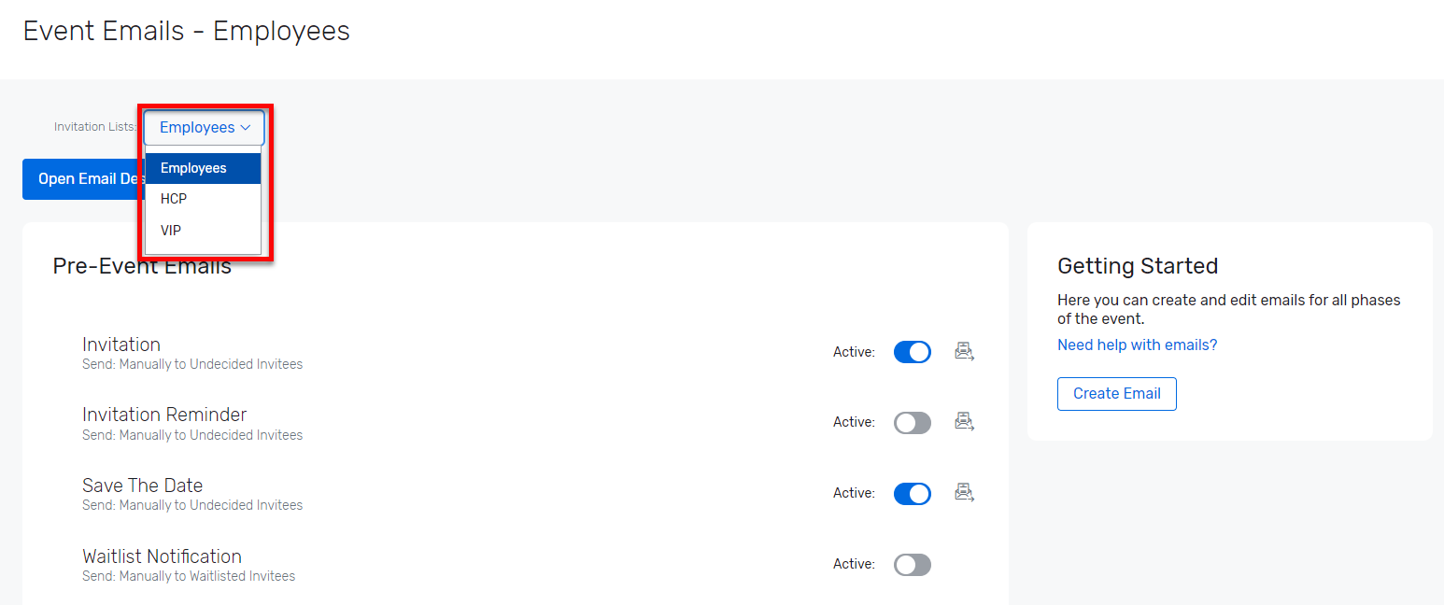
- To send an email, such as the invitation, click on the name of the email.
- Then under the Send drop down menu, select Manually, or click Edit to schedule the email under “Send Settings”.
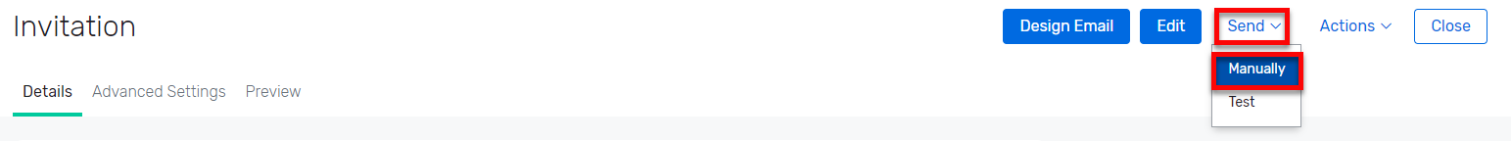

Changing Email Content
- The Cvent system has robust tools for customizing email content and the following outlines the basic steps and functionality that users can follow.
- Click on the email name, such as Invitation (Reminder: this can be customized by invitation list).
- At the next page, click Design Email.
- There are many of the same Design Tools options as when building the event website.
  - Click and drag in Widgets such as Text, Image, Button, etc.
  - For example, click and drag in an image widget and insert an image.
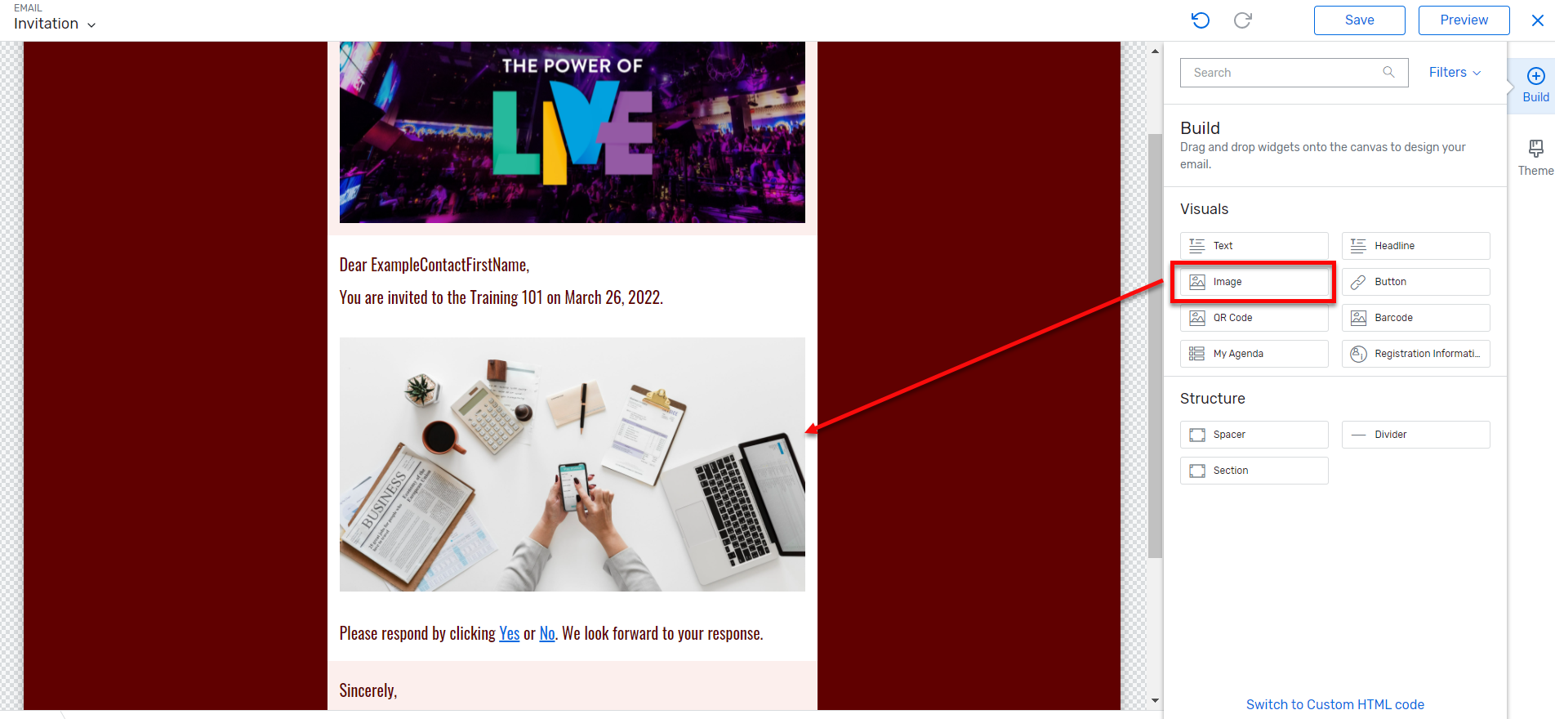
- To edit a Text Box, click on the box and a menu will pop up that can be used to format options and insert Cvent Data Tags.
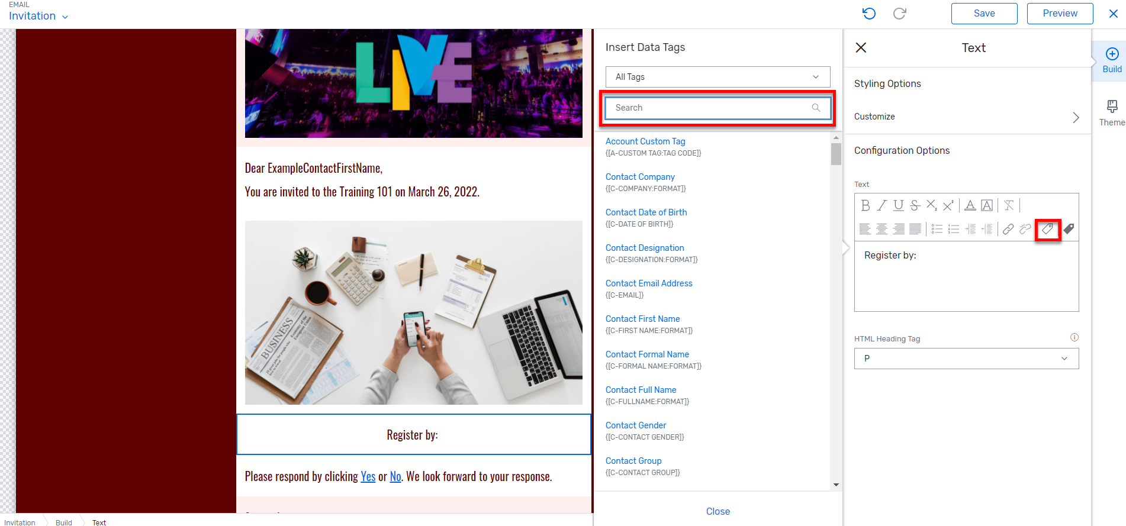
- Inserting Data Tags
  - Click on Data Tags icon and a window opens that provide all the available standard tags.
  - Click on the All Tags drop down to see the categories.
  - Select a category to find the appropriate tags.
- Frequently used tags can be flagged as Favourite Tags by clicking on the star, which then turns Gray.
  - There is also a Recently Used Tags category that will expedite searches.
  - For commonly used data tags, check-out the data tag cheat sheet.
- Once edits have been saved, see how it will look in an email by clicking the Preview button.
- In Preview mode, there is an option to switch views between Desktop, Tablet and Mobile.
- Select a different email to preview from the left Email dropdown.
For more information on designing emails, refer to this article in the Cvent Support Community.

Schedule Emails
To schedule an email, follow the steps below. Note: some emails cannot be scheduled because they are triggered by an action. For example, the registration confirmation email is triggered by an invitee registering and cannot be scheduled.
- Under the Email section, choose Event Emails.
- Click on the name of the email to open the email details.
- Click Edit.
- Change the send settings from Manual to At the following date and time.
- Choose the date, time and time zone then click Save.

Using events for Standalone emails (Newsletters and Board Nominations)
Within the MPI Global account, chapters can utilize events as a way to send communications like newsletters or board nominations. Follow the suggestions below for setting this up.
- Cvent recommends creating an event for the purpose of sending out eMarketing and email campaigns using Cvent events without the registration feature.
- Create the event
- Utilize the invitation lists to determine who should receive your communications
- Create event level emails to use as newsletters, eMarketing, etc.

Managing Invitation Responses
- Click on Attendees to manage attendees.
- Select Attendee List.
- On this page, select all or multiple attendees and under Bulk Actions, there is an option to send emails to all or selected attendees, update the contacts group and export the attendee list.
- The view dropdown can be used to filter the list by response status.
- Attendees are not categorized or organized by Registration Type in the Attendees section by default, because a registration type typically has not been assigned to an individual who is invited but has not yet registered. However, the custom view option can be used to create a view that displays the registration type and/or a number of other fields.
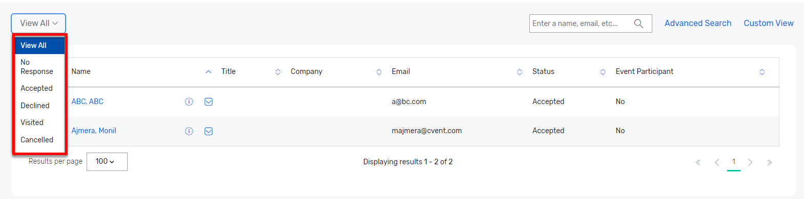
- Register Attendees manually using the Register Attendee button or add invitees under Actions dropdown, Add Invitees.

Testing and Launching the Event

Testing the Event
Always test an event prior to launch. Note, once a site is made live, preview can still be used, but the testing feature goes away. Because of this, it is not recommended to add new paths once a site is live, as it will not be possible to test the registration process without actually registering. More information about testing events can be found here.
Please note: Test scenarios will open in another tab. If the test does not appear, enable popups . If still struggling to test, try using a different browser, or emailing the test scenario(s).

Launching the Event
Once the event is ready, it is time to launch the site. More information can be found here.

Create a Feedback Survey
Set up a feedback survey so that it can be sent to registrants through the Event Feedback Email or a weblink. The template already has default questions built into the survey, but questions can be added, removed or modified. For more information on setting up a survey, refer to this article in the Cvent Support Community.

Event Level Reporting
Event level Reports are found in Attendee Management.

Running a Report
- Begin in the event and select Reports under the Reports menu section.
- By default, saved reports will appear first. To see a list of existing reports organized by report type, click the Report Templates tab.
  - The list of reports can be narrowed by selecting the type of report from the Category dropdown menu.
- Click the name of the desired report.
- The report will automatically run and redirect to the report’s details page.
- Edit report settings, filter the results, and change reporting fields within the report data settings dropdown in the upper right-hand corner.
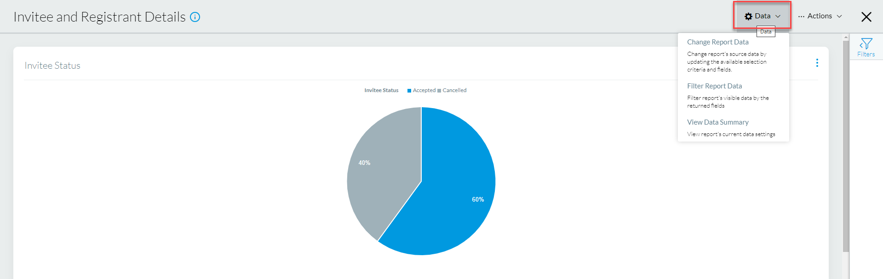

Setting the Report’s Criteria
- Under the Selection Criteria tab, select the date range, invitee status, currency, and other report-specific criteria.
- To determine which fields will display, click the neighboring tab, Fields.
  - Click the icons to determine what will/will not display in the report.
  - The fields with the + can be added to the report, while the fields with the checkmark are already associated to this report.
- Once done, click Run.
- To make changes to the selected data after the report has been run, hover over Data, and click Change Report Data.

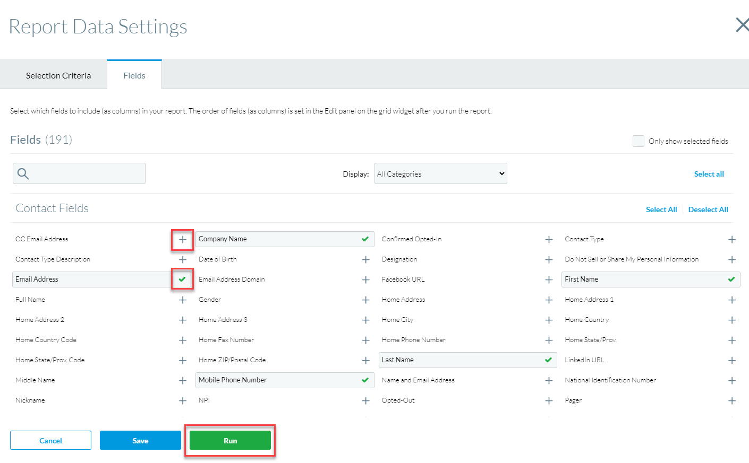

Filtering the Report
- To add a filter to the report, hover over Data and click Filter Report Data.
- Establish how the information will be filtered.
  - Filters and functionality vary by report.
- Click Apply.

Editing Grid Settings
- To filter data further, hover over the ellipsis (...) in the top right of the report's chart or grid, then click Edit.
  - It is possible to remove a column, group the data, view data summaries, or customize the graphs.
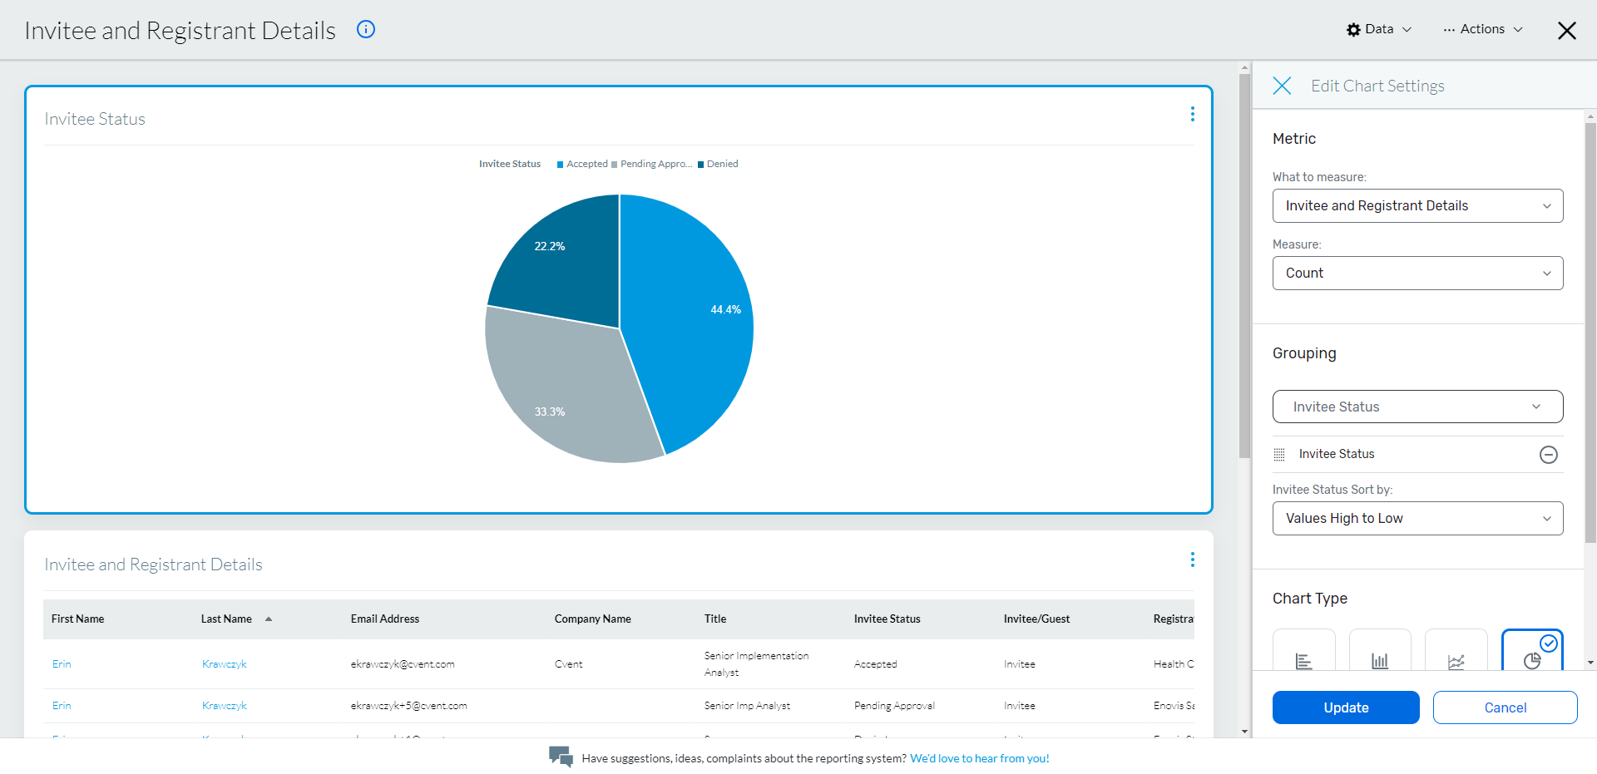

Saving and Exporting Report Data
Saving a Report
- After customizing desired report to include desired fields and filters, hover over the Actions menu on the report details page.
- Click Save As.
- Name the report.
  - Optional: add a description about the report. Reports can be scheduled to run at specific intervals. Note, scheduled reports do not send in an email. An email notification will go out, but the recipient will still need to log in to Cvent to view the report. This is an ideal option for if it is important to know what registration data looks like at specific points in time, rather than viewing current data when needed.
- Click Save.
- To run the report again, access the Saved Reports tab, then click the name of the saved report.
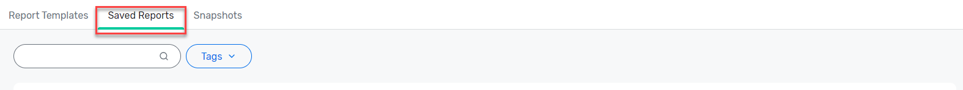
Exporting Report to File
Download report data to a spreadsheet file (.csv, .xlsx, and .txt formats available).
- After customizing desired report to include desired fields and filters, hover over the Actions menu on the report details page.
- Click Export.
- Choose the preferred format for the export.
- Optional: rename the file with a preferred title.
- Click the green Export button.
- Document will download and can be opened in preferred program.

Best Practices

- Utilize registration types within the template for integration with MPI Membership Status.
- During registration process, invitees will be redirected to MPI Global to login and confirm their membership status.
- Keep the registration paths created in the event templates in order to utilize the integration that will track MPI membership status.
- Use custom registration questions to collect data for future programming.
- Enable waitlists for high-demand sessions.
- Offer group registration discounts for member organizations.

Assistance and Resources
- Reach out to the System Administrators during normal business hours for assistance
  - Aniket Gupta
    - Aniket.Gupta@cvent.com
  - Shoaib Mauloodi
    - MShoaibmauloodi@cvent.com
- Access the Cvent Support Centre from within your account for knowledge base articles, training and case submission by clicking on the Cvent Community chat icon.
- For urgent issues, use the premium support line (US: 855.332.2728; international numbers in Support Center).
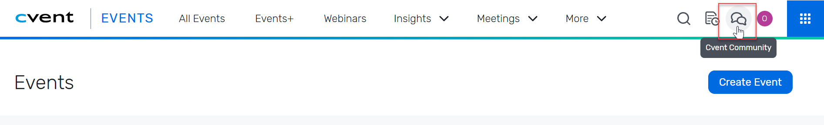

Cvent Community & Customer Care
The following resources can be found and explored by going to https://community.cvent.com/home.

Training Opportunities
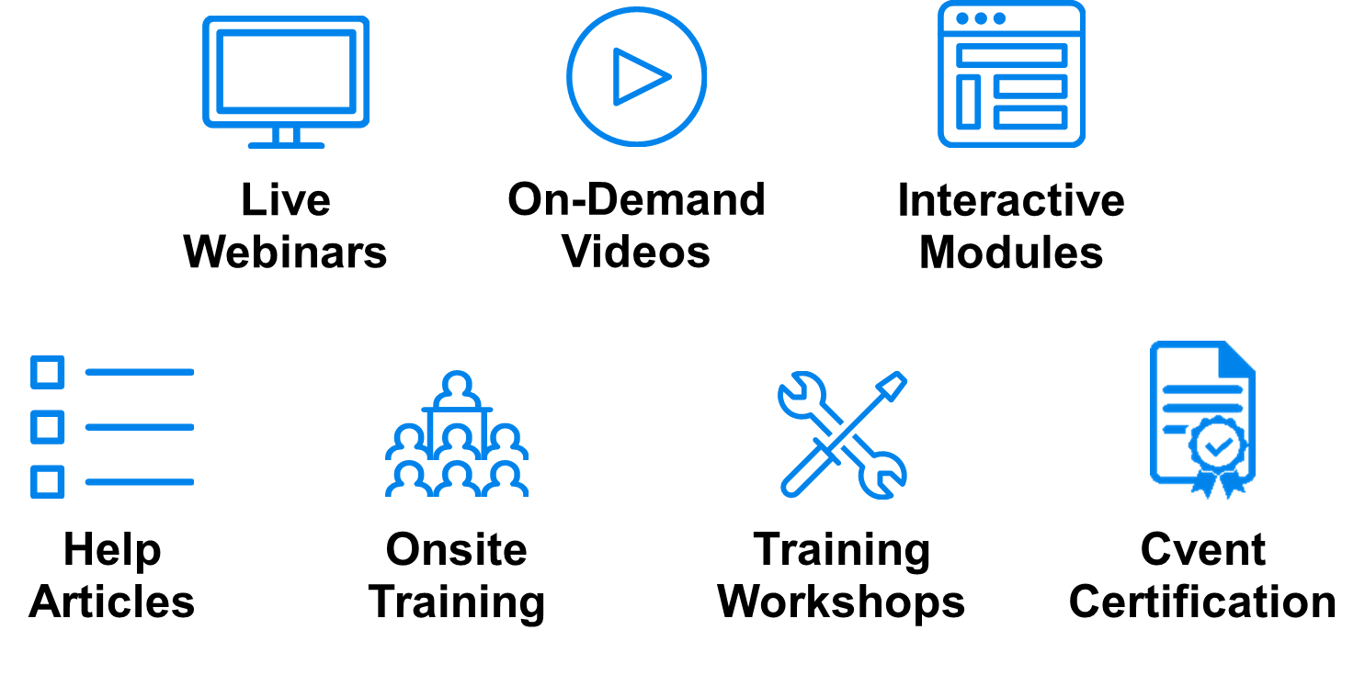
The following training opportunities can be found and explored by going to https://community.cvent.com/training.

