**Understanding the Data Discovery Reports**

The membership data discovery report is a document to assist the chapter in looking at the breakdown of your membership, and to help you understand trends as it relates to new members, cancellations, and renewals. You should be reviewing these reports on a quarterly basis at your board meetings for patterns and concerns in your membership numbers. This report will assist you in developing a proactive membership plan to target the patterns in your membership.

**Membership Overview Dashboard – Page 1**

**Membership Total Month End**

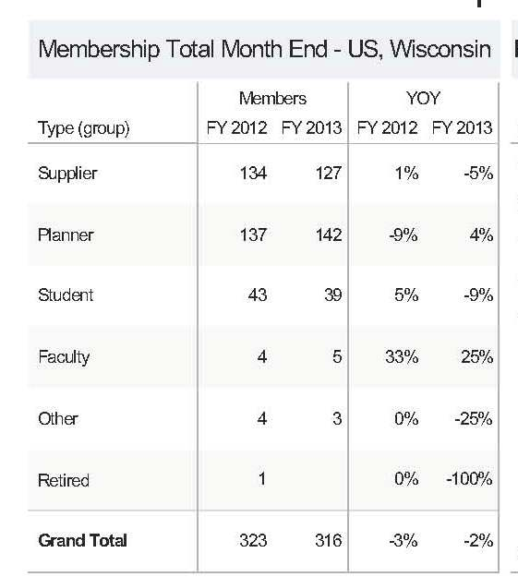

- The first column represents breakdown by membership category.

- The Members column shows a breakdown of your membership numbers in the month that the report is printed, and compares that number to the same month of the previous year. (FY= For Year)

- The YOY (Year over Year) column compares the percentage of loss or gain in each membership category from the previous year to the current year.

**Population Maturity**

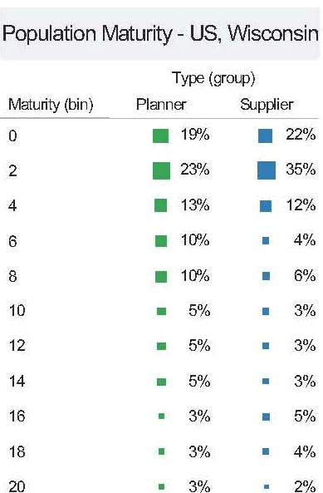

- The Maturity (bin) column represents the number of years your members have been in the chapter by supplier or planner. For example,

0 = new member - 2 years

2 = 2-4 years

4 = 4-6 years

- The next two columns represent the member category and the percentages under them represent the percentage of membership in that currently falls into each yearly segment of maturity.

**Financial Current**

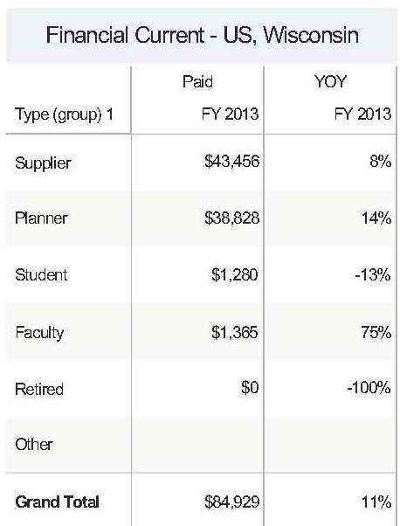

- This 1st column represents the total dollar amount that your members have paid in dues to MPI year to date.

- The 2nd column compares this year's member revenues to last year's revenues as a percentage increase or decrease.

**Membership Population**

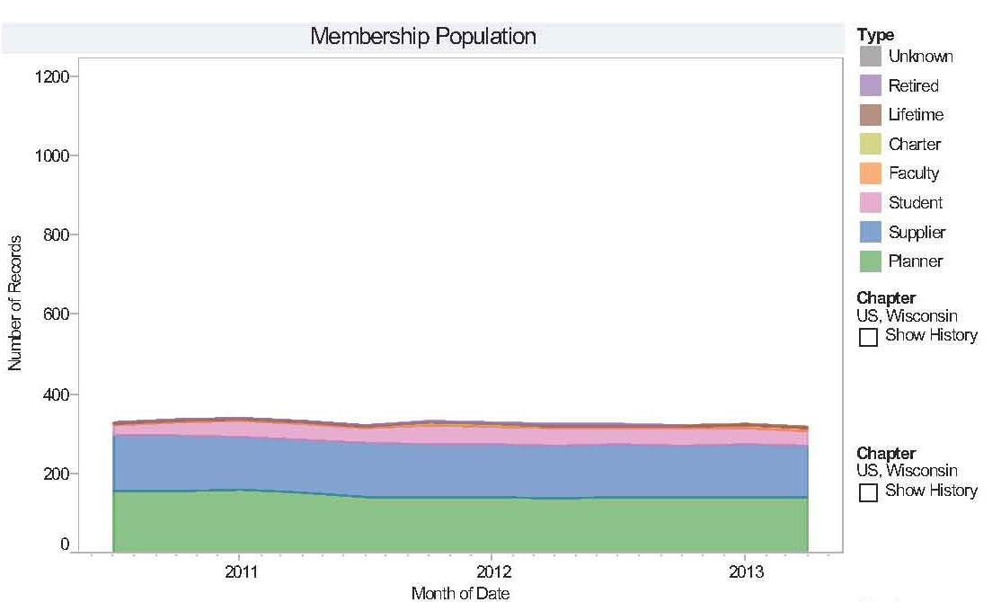

- This graph represents the different membership categories from the last 3 years, so that you can see any trends that have taken place over that time.

**Point in Time Retention Year to Date**

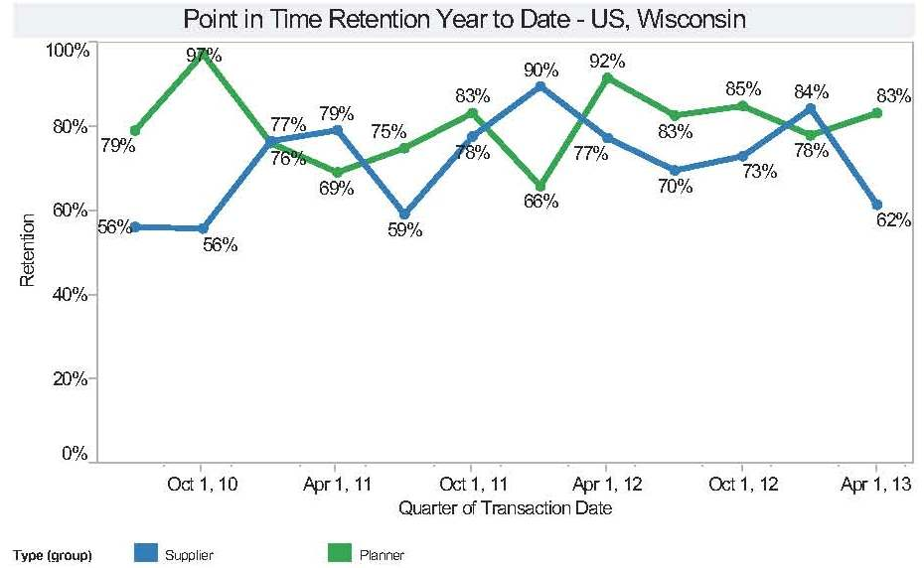

- This line graph represents multiple periods of time over the last 3 years to show how your member retention rate has increased or decreased during that time.

**% Gap Planner Supplier**

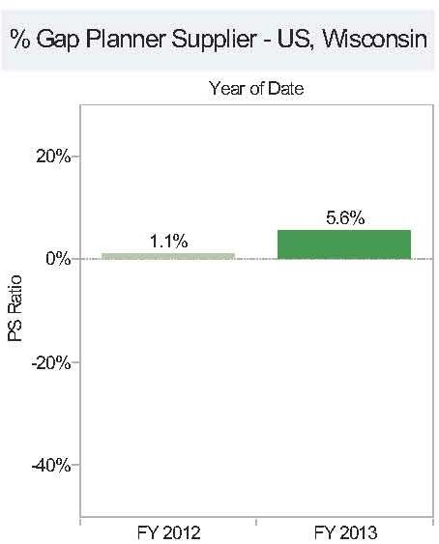

- This bar graph represents the gap percentage between your suppliers and planners. For example, if each graph was flat at 0%, that would mean you have an equal number of planners and suppliers in the chapter. A green bar, or positive planner/supplier ratio, represents that you have more planners than suppliers in your chapter. A red, or negative planner/supplier ratio, represents that you have more suppliers than planners in your chapter. So in the example above a 5.6% gap means that by looking at the planner/supplier population, 52.8% are planners and 47.2% are suppliers (a positive gap of 5.2 percentage point).

**Overall Quarterly Survey**

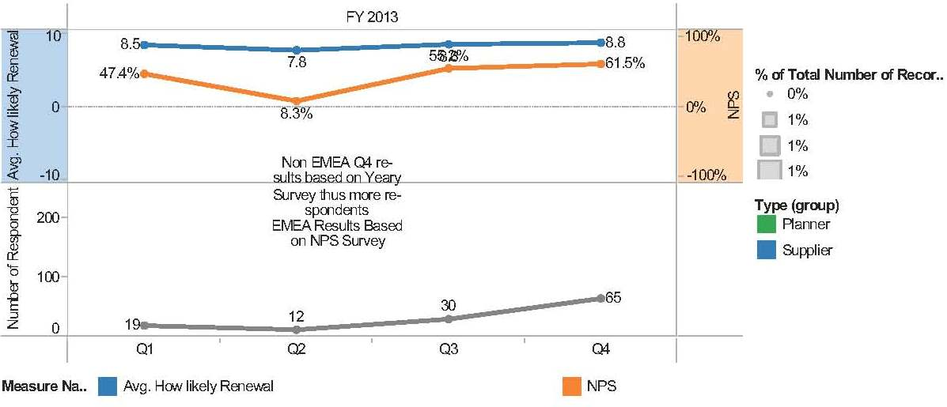

- During the 4 quarters of the year, an email is sent to a different group of your members to gauge their satisfaction with their membership. (These are the 6 month “How likely are you to renew surveys)

- The line graph on the bottom represents how many members completed the survey in each quarter, and the upper line graph gauges their response on two different questions. They are: How likely are you to renew your membership (blue line), and how likely are you to recommend MPI to someone else in the industry (orange line).

- The “How like are you to recommend MPI to someone” is translated into a NPS (Net Promoter Score.) For more info on the value of the NPS approach please use link below.

<http://www.netpromotersystem.com/about/measuring-your-net-promoter-score.aspx>

**Monthly Trend Dashboard – Page 2**

**Financial Monthly**

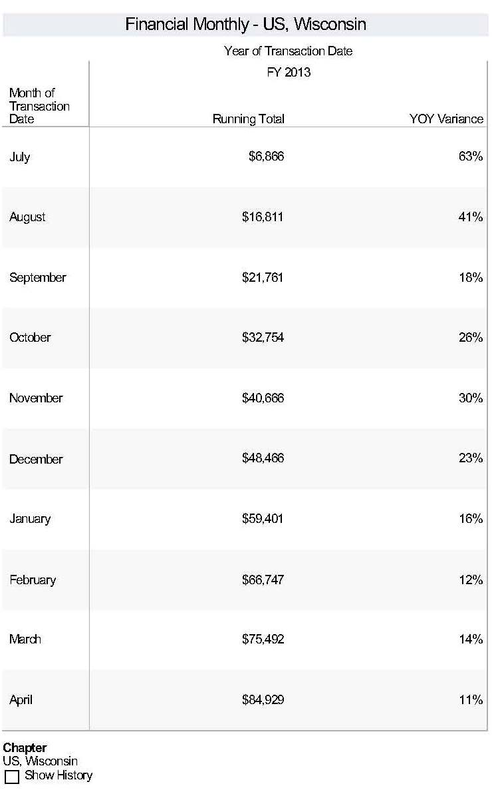

* This column is a running total of membership dues received on a monthly basis during the fiscal year. The YOY (Year over Year) variance compares this running total to the same time the previous year.

**YOY% Membership Change by Month End**

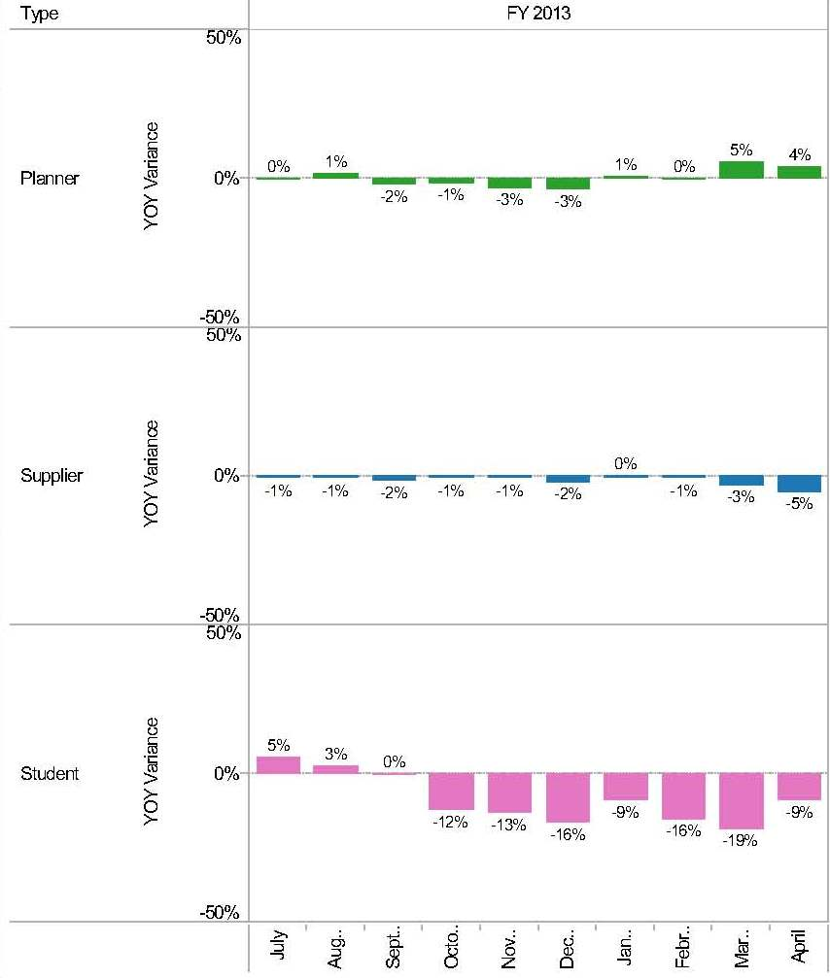

* This bar graph represents a monthly breakdown of the percentage of growth amongst your planners, suppliers, and students. This percentage encompasses all new members, renewals, and cancellations combined, so that your chapter will be able to proactively plan for when the largest increases and decreases take place during the chapter year.

**Monthly Net Rate of Change**

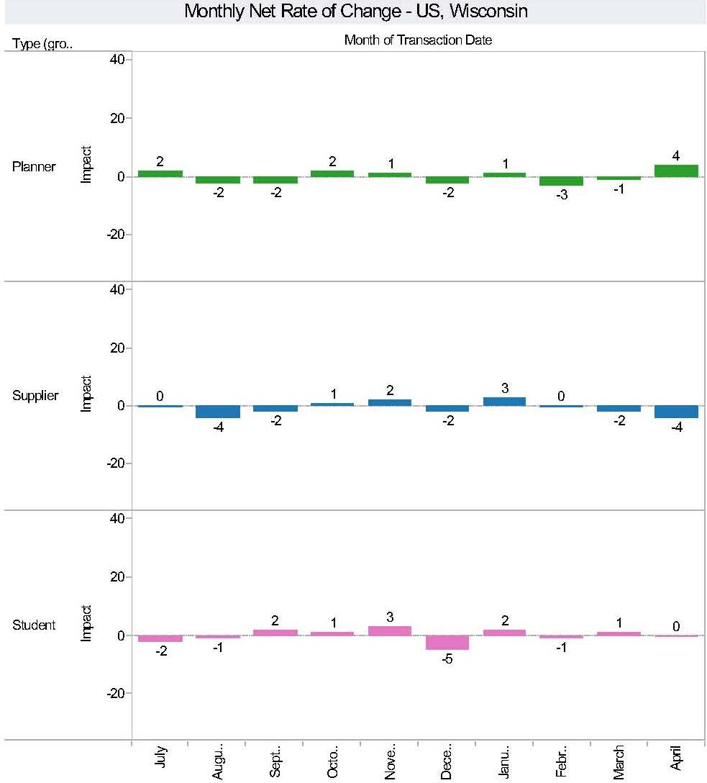

* This bar graph represents the net number of planners, suppliers and students that you gain or lose on a per month basis. Like the % membership change, the net rate of change is a combination of all new members, renewals and cancellations on a per month basis. By having the net rate of change, this will give your chapter a better indication of how many total - planners, suppliers and students reflects in your membership numbers on a monthly basis.

**Cancellation Renewal – Page 3**

**Who is Cancelling**

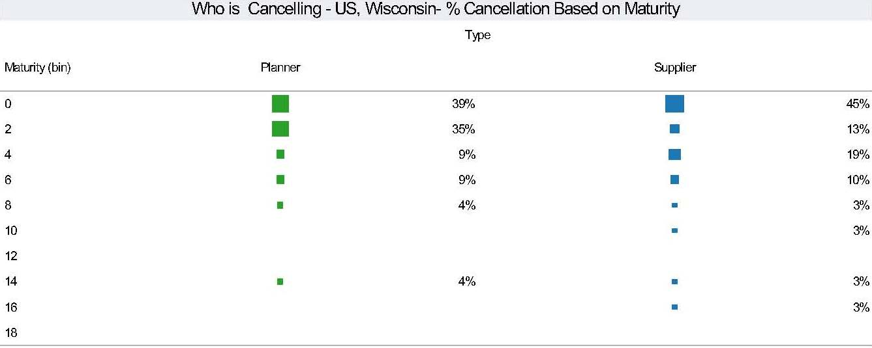

* This graph breaks down per month who amongst your planners and suppliers is cancelling based on the number of years they have been members. This will give the chapter a better idea if they are losing newer members vs. those that have been members for a longer period of time.
* This view can be compared to the Population Maturity View on the first page to identify areas of cancellation issues. In this example, new members represent a very high percentage of cancellations, which is resulting in a challenge with retention for new members.

**Who is Renewing or Rejoining**

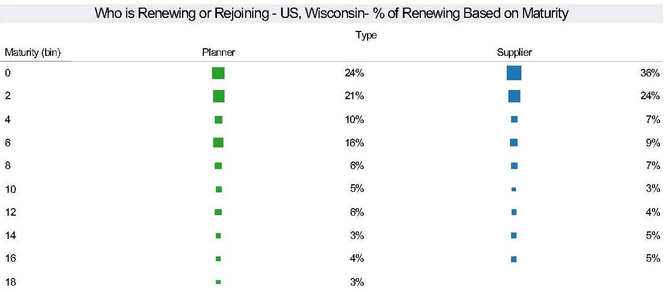

* Similar to the “who is cancelling” graph, this graph represents a monthly breakdown of your planners and suppliers renewing their membership or rejoining MPI based on how many years they have been members.

**Why are they Cancelling?**

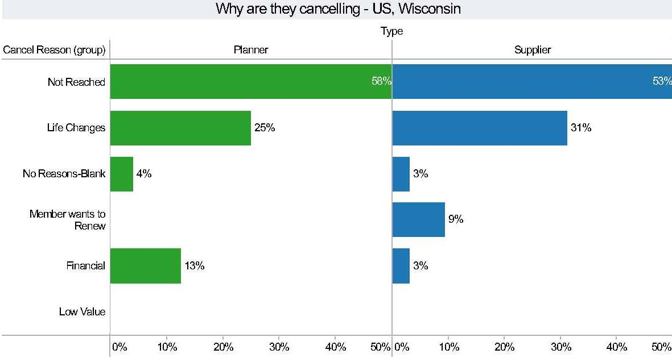

* This bar graph summarizes the main reasons why a member is cancelling a membership. These categories include:

1. Not reached – A member did not respond to emails or telephone calls as to why they were cancelling their membership.
2. Life Changes – This includes loss or change in jobs, no longer in the industry, etc.
3. No Reasons – blank – This was a member who was able to be contacted, but did not provide a reason as to why they were cancelling.
4. Member Wants to Renew – A member is planning on renewing but is waiting for their employer to provide payment, or the member themselves has not had a chance to pay for their membership.
5. Financial – Either their employer or the member themselves does not have the funds available to continue paying for a membership.
6. Low Value – The member doesn’t feel they are getting the full value out of their membership.

**\*\*By comparing this graph with the “Who is Renewing or Rejoining” and “Who is Cancelling” graph, it will allow you to compare who in your membership are the most at risk of canceling their membership and when\*\***

**Monthly Rate of Change**

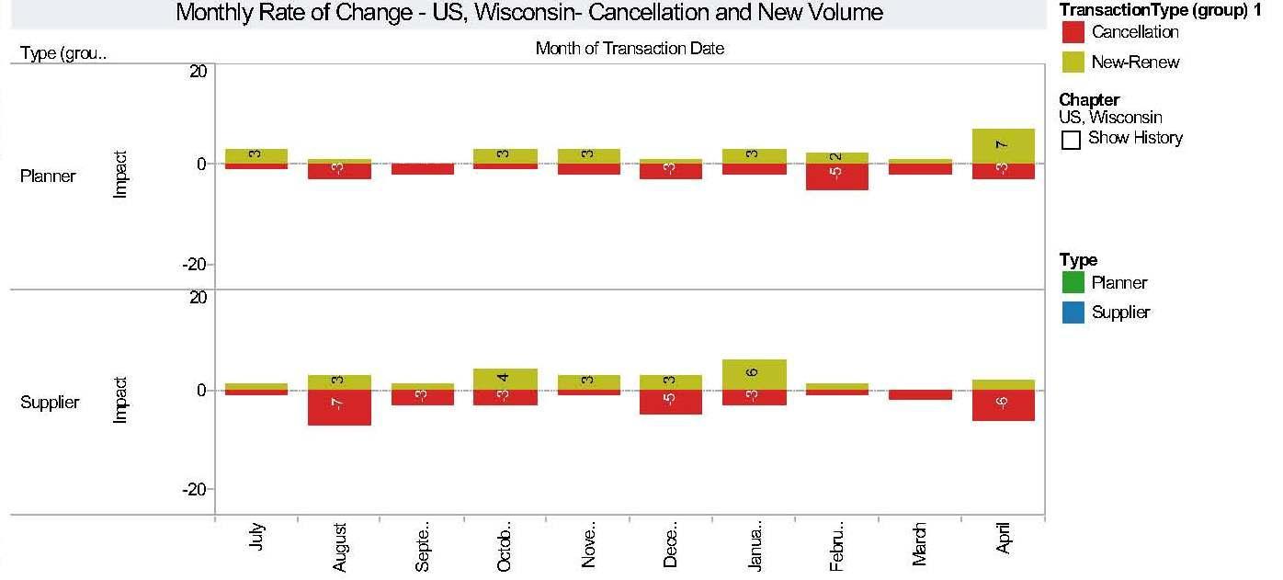

* This bar graph provides a monthly breakdown of planner and supplier new/renewals and cancellations. This information is helpful to show those months where you have the strongest and weakest growth, so a chapter can put proactive recruitment plans in place for those months that typically experience a higher decline of cancellations.

**Seasonality Net**

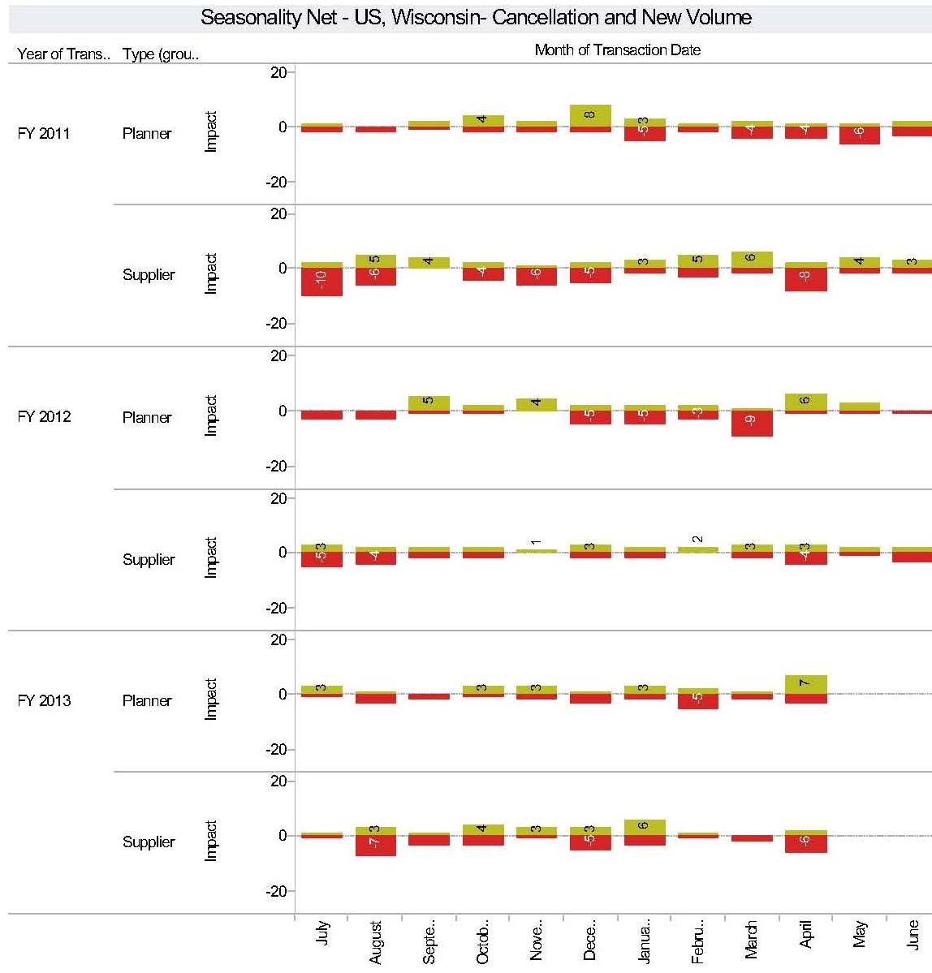

* This bar graph provides a 3 year history of changes in net membership with your planners and suppliers. By having this history, a chapter can take a look to see what trends have been taking place in membership increases and decreases over the years.

**YOY % Membership Change**

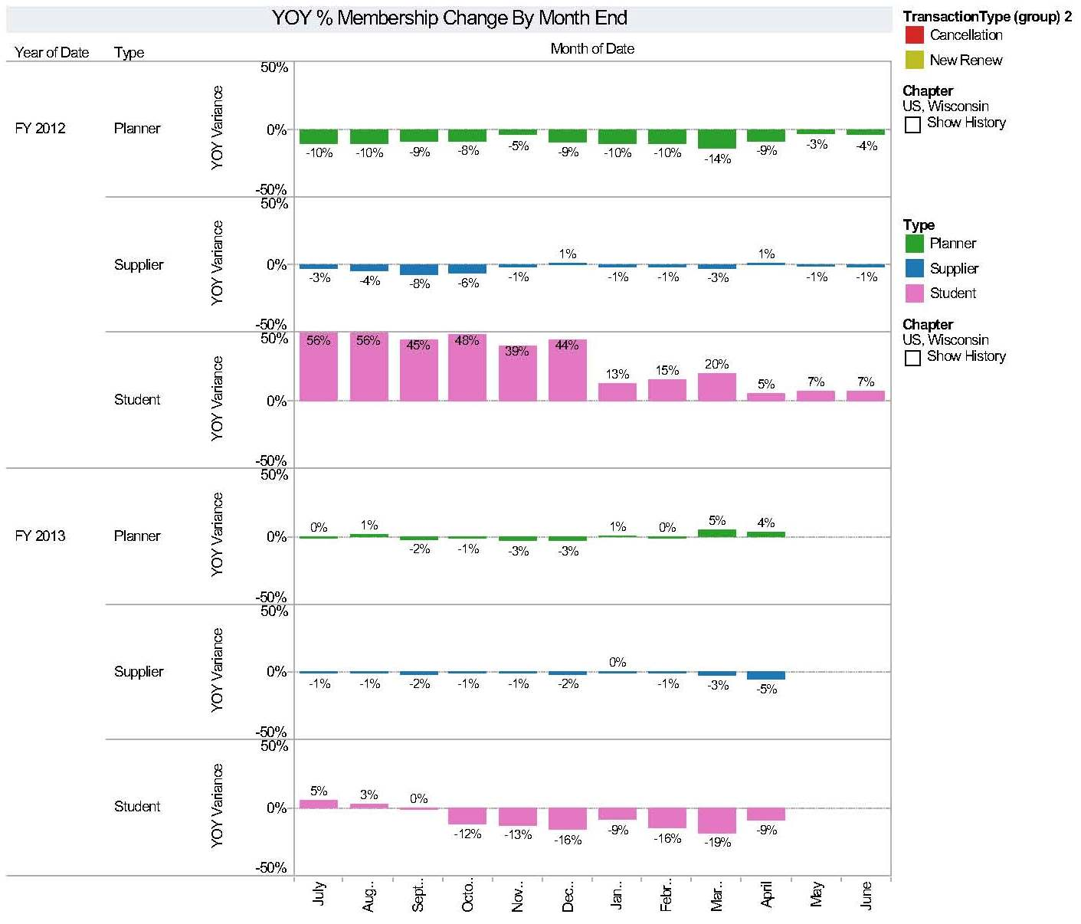

* This bar graph represents the past 2 years of membership percentage growth and losses in your planner, supplier and student member categories. This information is helpful in reviewing trends in membership numbers, which will help to focus recruitment efforts by membership category.

**Benchmarking Dashboard**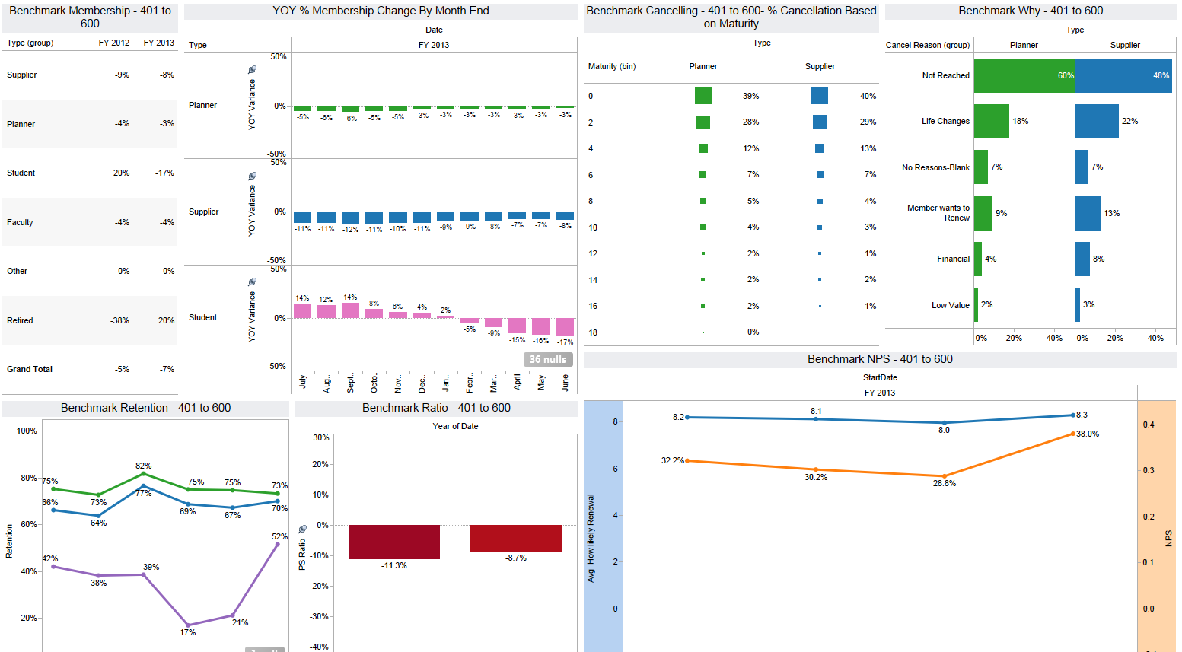

* This view is similar to a chapter specific dashboard but it represents a benchmarking view based on chapter size or region. It will help in identifying if some trends are chapter specific or are impacting other similar chapters and thus highlight areas of strengths or weaknesses.