**Chapter Brand Positioning Worksheet**

***Section I:*** *Defining the chapter’s strategy* – answer the following questions to define your chapter’s identity and identify areas of opportunity.

What is our chapter great at? 1. ________________________________________________

2. ________________________________________________

3. ________________________________________________

What do we want our chapter to be? _________________________________________________

What is our chapter challenged with? 1. ________________________________________________

2. ________________________________________________

3. ________________________________________________

***Section II:*** *Developing the chapter value proposition* – this statement should combine the chapter’s Brand Promise, Brand Value, and Brand Personality. This part takes time, however, by filling out the worksheet below, you will be able to articulate your value proposition clearly & concisely:

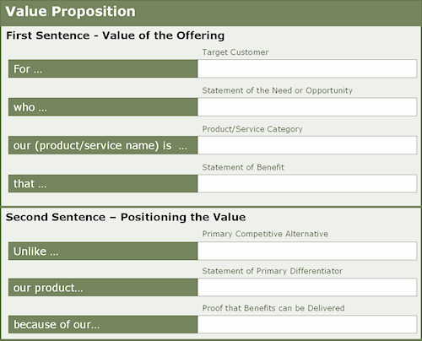

***Section III:*** *Taking stock of your communications plan*. What platforms is your chapter utilizing? Are they effective and engaging to your membership? List your communications platforms below and rate their effectiveness:

1. ______________________________________ Effective & Engaging? Yes No Unknown
2. ______________________________________ Effective & Engaging? Yes No Unknown
3. ______________________________________ Effective & Engaging? Yes No Unknown
4. ______________________________________ Effective & Engaging? Yes No Unknown
5. ______________________________________ Effective & Engaging? Yes No Unknown
6. ______________________________________ Effective & Engaging? Yes No Unknown
7. ______________________________________ Effective & Engaging? Yes No Unknown

Could you leadership team increase the effectiveness and engagement of these channels if an organized, easy to use, and simple marketing calendar was implemented?

***Section IV:*** *How do you Chapter communications feel?* – A great brand will evoke feeling, by taking an account of how your members feel when they are interacting with your brand, you will be able to make adjusts to move your brand from good to great!

From your member’s perspective, how do you feel **honestly** when you interact with the following?

1. Chapter Website: _____________________________________________
2. Marketing Materials (email & print) _____________________________________________
3. Chapter Social Media Sites _____________________________________________
4. Educational Programs _____________________________________________
5. Social / Special Events _____________________________________________

Section V: Let’s roll out the branding program! Utilize this checklist to ensure that you are sounding adjusting your chapter’s brand to increase the value to your membership.

**Setting a realistic timeline** – Branding doesn’t change overnight, remember, “Crawl, Walk, Run”

**Website adjustments** – What tweaks can be made simply, with minimal costs?

**Email marketing best practices** – Begin to employ some different strategies, measure and adjust

**Social media ambassadors** – Identify and embrace these members

**Marketing Liaisons** – establish these positions throughout your Board of Directors

**More is not always better** – Focus in your efforts and live your brand

**Measure, analyze, and adjust** – Change your techniques constantly to meet your brand strategy

**The full information from this session is available on the Chapter Leaders Resources Page**[**http://www.mpiweb.org/chapteradmin**](http://www.mpiweb.org/chapteradmin)